Establishing an International Law Framework for the Trump Tariffs
Kulsum Gulamhusein
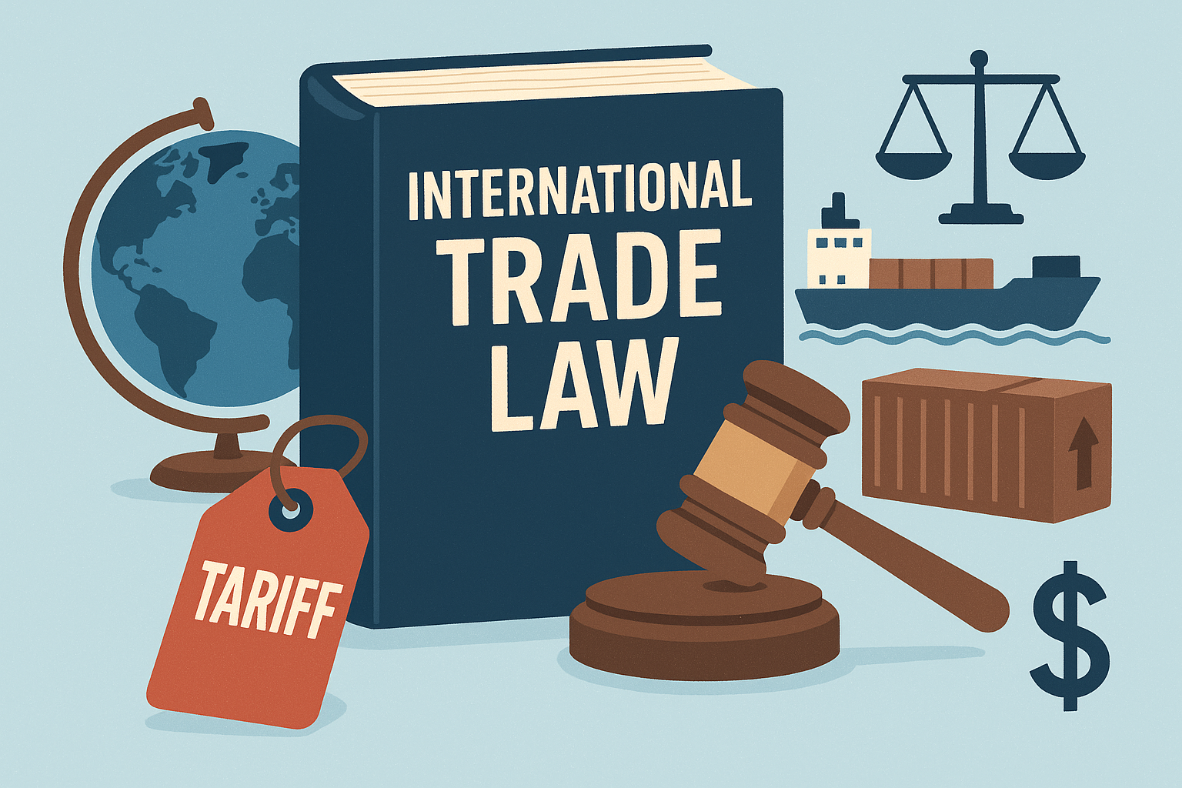
- Introduction
“Liberation day” and the introduction of Trump “reciprocal” tariffs signal a final step in the shift away from the World Trade Organization (WTO)-based rules based international trading system. The world has dramatically changed from the one that existed when the WTO international trade law framework was implemented, yet there has been little in the way of updates to allow the WTO to meet the current moment, including the rebalancing of the “terms of trade” that many countries deem to be essential to future economic success.
Economists and trade specialists predict that the future of international trade is instead to be based in a number of bilateral and plurilateral treaties that allow for “coalitions of the willing” to negotiate narrow treaties that address specific issues. This would take the form of a fragmented global trading system that starts with the introduction of reciprocal tariffs and breaks down into a web of bilateral agreements with different rules, therefore introducing complexity for companies trying to navigate varying tariff rates.
While the U.S. has justified its “reciprocal” tariffs as fitting into a national security exception in the WTO agreement, there is a high chance that they actually violate international trade law rooted in the General Agreement on Trade and Tariffs (GATT) and WTO founding documents and they may also violate U.S. law. The U.S. government defines reciprocal tariff policy as “rebalance[ing] global trade flows by imposing an additional ad valorem duty on all imports from all trading partners”. In practice, this is the application of a baseline ten percent tariff on all imports from all trading partners, and then an additional ad valorem duty calculated based on the U.S. trade deficit with each trading partner. Applying an existing international trade law framework to these actions would make them legal under international trade law and preserve the integrity of the existing international trading system.
There are few countries that will be unaffected by the new U.S. tariff regime and the bilateral negotiations that follow. The Trump administration has focused its energy since liberation day on negotiating new bilateral trade agreements with individual nations, something that undermines the relevance of the WTO and poses issues for countries still interested in complying with the existing international trade law framework. While the WTO undoubtedly faces issues in its ability to face this moment, it could still provide a useful international law framework from which to approach this issue. There is evidence that while the U.S. may not value the WTO, other members still view it as an important pillar of international trade. Therefore, this report considers the impact of the new U.S. approach to international trade law on WTO members, and whether the same goals might be achieved using the existing international trade law framework.
- Background
The current multilateral trading system is based on the GATT and the WTO. The GATT was established in 1947 with twenty three Contracting Parties, providing a set of rules for multilateral trade. From its establishment until the establishment of the WTO, the GATT expanded to include 128 Contracting Parties, covering 90 percent of world trade. The WTO was established in 1995 through the Uruguay Round of negotiations under GATT. The GATT was incorporated into the WTO’s more enduring institutional framework and is still a source of international trade law today. The WTO was built on the idea of a reciprocal balance of trade concessions and incorporated all of the GATT contracting parties as well as several new members, including China.
The U.S. has not always been happy with the constraints of the multilateral trading system, however in the past this has led to development and adaptation of existing structures, rather than the establishment of an alternative system that violates existing laws. In the 1980s, the U.S. used unilateral sanctions and trade agreements to bring about progress on stalled GATT negotiations. These actions led to the creation of the WTO and provisions to address areas of concern to the U.S. such as intellectual property and services.
The power of MFN has declined since the signing of the GATT in 1947, most notably with the negotiation of “plurilateral agreements” in the Tokyo Round (1973-1979) and then with the establishment of the WTO in the Uruguay round which abolished the GATT per se and implemented a new agreement including the GATT but also numerous exceptions to MFN for industries such as financial services and information technology. Since the Uruguay round, numerous unilateral and regional trade agreements have continued to undermine MFN.
The continued implementation of new tariffs as a part of U.S. policy reflects a global trend towards “economic nationalism and controlled trade.” Even if tariffs are necessary to creating a more equitable and reciprocal trading system, a better outcome could be achieved if the U.S. utilized existing international trade law mechanisms to achieve a global trade resetting rather than compelling trade partners to engage in negotiations through damaging unilateral tariff actions. Using existing international trade law mechanisms would preserve the integrity of a global trading system that it appears U.S. partners are not yet willing to overthrow.
- Violations of International Trade Law
Under the WTO agreement, each member country agrees to cap tariff rates at a certain rate with all members, creating a most favored nation (MFN) rate. Article I:1 of the GATT creates the MFN principle which requires a member to “give equal trade treatment to all other members.” MFN means that countries cannot discriminate between their trading partners, and when they grant special treatment to one member, they must do the same for all members. There are some exceptions allowed, such as the national security exception which the U.S. is currently invoking, but only under strict conditions. Countries also agree to a maximum rate of tariffs in their WTO schedules. When a member raises a tariff above this rate, affected countries can challenge that action at the WTO. While the universal ten percent tariff imposed on all nations works within this framework, both the reciprocal tariffs imposed by the U.S. and bilateral treaty negotiations following the imposition of the tariffs violate this principle.
Only bilateral agreements that cover “virtually all trade” between nations are allowed under WTO rules as an exception to the MFN rule. Therefore, the new bilateral agreements, which tend to only cover specific sectors, would require the U.S’s WTO-compliant trading partners to extend terms to all WTO members. For example, under MFN rules, partners like the UK would extend all of the benefits afforded to the U.S. in the new deal to other WTO members. As the U.S. negotiates an increasing number of bilateral agreements across the world this will only fragment and complicate the trade relationships between other WTO member states.
- U.S. Unilateral Action Within the WTO Framework
While current U.S. unilateral action violates existing international trade law as a WTO member, there are mechanisms within the existing framework that would allow for a resetting of U.S. tariff rates that allow WTO members to equally participate in negotiation.
Article XVIII of the GATT allows any WTO member to unilaterally change its tariff commitments, subject to negotiating compensation with those countries that are most affected by the tariff change. Although the U.S. has not triggered Article XVIII, it is essentially putting into practice the mechanism of Article XVIII by announcing that it wants to renegotiate its tariff commitments. Article XVIII would allow the US to unilaterally raise its tariffs with or without striking new deals with trading partners. However, the mechanism also allows trading partners to retaliate by suspending their own trade deals with the US. Routing U.S. tariff action through the WTO would allow for the existing international law trade framework to be maintained and would avoid conflicts between partner countries’ desire to negotiate with the U.S. and continue to participate in the WTO.
- Bilateral and Plurilateral Agreements
Following the “liberation day” announcement, the U.S. signaled willingness to negotiate bilateral agreements with trading partners to negotiate the level of the reciprocal tariffs. Bilateral agreements violate the fundamental principle of the WTO which is to promote multilateral trade negotiations. Future bilateral trade agreements, such as the U.S.-UK economic prosperity deal look to be much more bare bones than those of the past, with some consisting of “agreements to agree” and specific terms to be worked out in the future. The text of the agreement makes it clear that this is not a legally binding agreement.
Instead of the US negotiating bilateral agreements with every trading partner, it seems that a more efficient method of negotiation could be for countries with similar goals to team up and form “coalitions of the willing.” Even countries that reach bilateral agreements could later work to transform those agreements into plurilateral agreements. However, rather that creating these agreements outside the WTO, WTO director-general Ngozi Okonjo-Iweala has suggested that there could be space within the WTO framework to work this out. Even if the US is no longer committed to the WTO framework, many of its trading partners are. Utilizing the existing WTO framework could lead to a rebalancing of the broader trade system, rather than just a rebalancing for the US. Using Article XVIII would incorporate bilateral deals made by the US into the WTO structure. This process could also start a domino effect drawing in other major trading nations to the renegotiation process, leading to a resetting of the entire trading system rather than just the US’s trade relationships. The WTO is built on the same reciprocity principle underlying the new US tariffs, and using this existing institution and its trappings of international law allows the opportunity for a global resetting of trade relations, rather than one made up of fragmented and unspecific bilateral and plurilateral coalitions and treaties.
- Conclusion
Rather than continuing to violate international trade laws and undermine the multilateral trading system, there is space for the U.S. to achieve its goals within the GATT/WTO framework. Utilizing this system would allow the U.S. to reset the multilateral trading system to achieve equity in the modern trading world, while drawing more trading partners into negotiations. This solution would allow partner countries to continue engaging with both the U.S. and WTO framework, upholding a clear system of international trade law.

Joost Pauwelyn, How the US Reciprocal Tariff Plan May Save the Global Trading System, 24 World Trade Rev. 509, 511 (2025).
Id.
Trade, Why the Most-Favoured Nation Principle Matters for Business, Int’l Chamber of Com. 2025, https://iccwbo.org/wp-content/uploads/sites/3/2025/03/2025-ICC-Why-the-most-favoured-nation-principle-matters-for-business.pdf.
James Bacchus, The Black Hole of National Security: Striking the Right Balance for the National Security Exception in International Trade (Cato Inst., Policy Analysis No. 963, 2022).
Exec. Order No. 14257, 90 Fed. Reg. 15041, 15045 (Apr. 7, 2025).
Id.
Alan Wm. Wolff, Senior Fellow, Peterson Institute for International Economics, Remarks Prepared for Delivery at the World Trade Organization (Apr. 10, 2025).
Id.
History of the Multilateral Trading System, World Trade Organization, https://www.wto.org/english/thewto_e/history_e/history_e.htm [https://perma.cc/4KC6-VVVS] (last visited Nov. 18, 2025).
Kent Jones, The Global Trading System: What’s Left of the Most-Favored Nation Rule?, Fletcher F. World Affs., Summer 2025, at 85, 87.
Id.
Id. at 89.
See generally, id.
Pauwelyn, supra note 1, at 511.
See Jones, supra note 9, at 86-91.
Pauwelyn, supra note 1, at 511.
Id.
Pinar Cebi and Rodney Ludema, The Rise and Fall of the Most-Favored-Nation Clause 1-3 (U.S. Int’l Trade Comm’n, Off. of Econ. Working Paper No. 2002-06-B, 2002) https://www.usitc.gov/publications/332/ec0206b.pdf
Id.
Cheng-Wen Lee and Adil Zareef Khan, The Impact of Trump’s Tariff Policies on Global Trade Dynamis: A Case Study of Major U.S. Trade Partners, Int’l J. Bus. and Econ. Affs., Mar. 29, 2025, at 62, 65.
Id.
Inu Manak, U.S.-UK Trade Deal Illustrates Trump’s Shifting Trade Policy, Council on Foreign Rels.: Greenberg Ctr. for Geoeconomic Stud.(May 9, 2025 at 14:49 ET), https://www.cfr.org/expert-brief/us-uk-trade-deal-illustrates-trumps-shifting-trade-policy [https://perma.cc/9ZL3-47MT].
General Agreement on Tariffs and Trade, Oct. 30, 1947, 61 Stat. A-11, 55 U.N.T.S. 194 [hereinafter GATT].
Principles of the Trading System, World Trade Organization: Understanding the WTO: Basics, https://www.wto.org/english/thewto_e/whatis_e/tif_e/fact2_e.htm [https://perma.cc/55C9-33H2] (last visited Nov. 18, 2025).
Id.
GATT, supra note 20.
Id.
Inu Manak and Helena Kopans-Johnson, Trade Agreements, Explained, Council on Foreign Rels.: Greenberg Ctr. for Geoeconomic Stud. (Aug. 12, 2025 at 16:57 ET), https://www.cfr.org/article/trade-agreements-explained [https://perma.cc/6MYG-28SJ].
Manak, supra note 19.
See generally Pauwelyn, supra note 1, at 511.
GATT, supra note 20.
Pauwelyn, supra note 1, at 512.
Id. at 513.
Id. at 513.
Henrik Horn and Petros C. Mavroidis, Why the US and the WTO should part ways, Vox EU Ctr. for Econ. Pol’y Rsch: Int’l Trade (June 15, 2025), https://cepr.org/voxeu/columns/why-us-and-wto-should-part-ways [https://perma.cc/6G57-LW2L].
Manak, supra note 19.
Pauwelyn, supra note 1, at 511.
Id.
Ngozi Okonjo-Iweala, A Stress Test for Global Trade, The Fin. Times (Sep. 4, 2025), https://www.ft.com/content/344ef0a3-eb77-4edb-abc0-48b167546f37?shareType=nongift [https://perma.cc/UYD5-PUAJ].
Id. at 512.
Id.
Id. at 512-513.
Id. at 513.
Id. at 511.

