Any Change in States’ Obligations re: Climate Change? A Closer Look at the 2025 ICJ Climate Advisory Opinion
Kratika Tandon
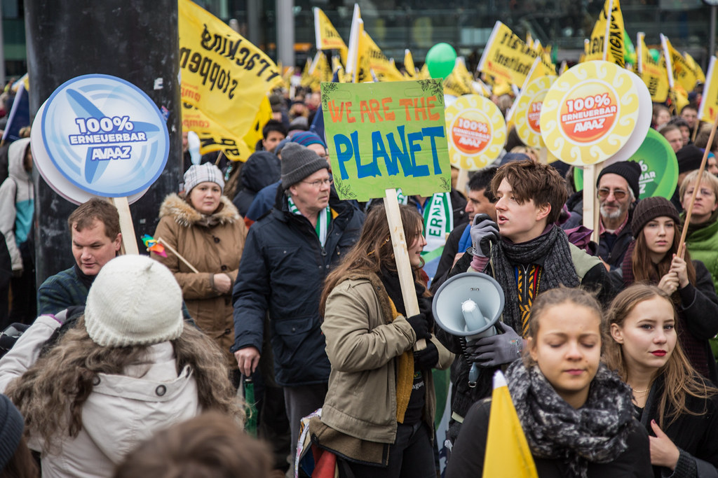
- Introduction
For decades, international law has struggled to keep up with the ever-accelerating threat of climate change. In July 2025, that dynamic shifted. The International Court of Justice’s (the Court, or ICJ) latest climate advisory opinion represents a turning point – clarifying, for the first time, States’ legal responsibilities to their people and to the planet.
On July 23, 2025, the ICJ published the latest body of work in the international environmental space: an advisory opinion on the Obligation of States in Respect of Climate Change. This decision was prompted in response to a March 29, 2023, resolution adopted by the General Assembly (GA) of the United Nations, in which the Assembly requested the Court to answer two questions.
In calling upon the ICJ, the GA requested clarification on pressing areas of concern in international environmental law. It asked, “what are the obligations of States under international law to ensure the protection of the climate system and other parts of the environment from anthropogenic emissions of greenhouse gases for States and for present and future generations?” Second, the Assembly posited the question of what legal consequences States may face under these obligations when they have caused significant harm to the climate system and broader environment.
Following extensive written and public hearing proceedings, in which 96 states and 11 international organizations presented oral arguments (the highest level of participation in a proceeding in the Court’s history), the ICJ issued its decision. Notably, this decision was rendered unanimously – only the fifth advisory opinion in the Court’s almost eighty-year history that has been so.
In reaching its decision, the Court characterized climate change as an “existential threat,” citing the dire, far-reaching consequences it will have on the global future. As a result, the ICJ answered that under current international law, which consists of climate change and environmental treaties, as well as customary international environmental and human rights law, states have clear obligations to protect the climate system, broader environment, and individuals. A breach by a State of any of the identified obligations constitutes an internationally wrongful act, consequences of which may include cessation of the act; providing guarantees of non-repetition; and full reparation to injured States in the form of restitution, compensation, and satisfaction.
This opinion is merely one development in the extensive domain of international environmental law, but no less significant. This report will trace the backdrop leading up to this decision and, in doing so, shed light on the opinion’s significance within the broader narrative of international environmental law. As this field of law continues to develop, states and industries alike will have to remain vigilant and re-evaluate their practices.
- International Environmental Law – A Brief Introduction
Across the planet, environmental crises and natural disasters continue to ravage habitats and communities. A majority of these problems can and will only be effectively resolved through interstate cooperation. The recognition of this fact is what led to the emergence of a distinct field of international environmental law in the 1970s. Ultimately, ecological interdependence has no respect for national boundaries, and issues that may otherwise have been viewed as domestic matters now present global implications, usually in need of international regulation.
Passed in 1968, GA resolution 2398 prompted the development of contemporary international environmental law. This resolution was the first to voice concern about the “accelerating impairment of the quality of the human environment,” sounding the alarm about the need for “intensified action at the national, regional, and international level.” A decade later, the 1979 World Climate Conference recognized the adverse environmental impacts that were caused by the burning of fossil fuels – particularly, through emissions of carbon dioxide.
The United Nations’ Intergovernmental Panel on Climate Change (IPCC) was created in 1988, comprising experts who provide governments with the scientific information needed to develop effective climate policies. Within two years, the IPCC’s First Assessment Report was published, noting that industrialized countries should take the lead in combatting manmade climate change, because a significant amount of the emissions affecting the atmosphere originated in those nations where scope for change was the greatest. These findings subsequently underscored the provisions of the 1994 United Nations Framework Convention on Climate Change (UNFCCC).
To effectuate the UNFCCC by committing industrialized countries to limit and reduce their emissions, the Kyoto Protocol was adopted in 1997. This treaty established binding, country-specific emission reduction targets which were to be achieved during “commitment periods.” The twenty-first Conference of the Parties to the UNFCCC took this objective one step further through the adoption of the 2015 Paris Agreement, which requires all countries to set emissions targets with the goal of maintaining global temperature rise below 2C above pre-industrial levels.
Together, these treaties and conferences trace the evolution of international environmental law from preliminary awareness to current progress toward coordinated global action. This historic progression provides the backdrop to analyze contemporary efforts to confront climate change through international cooperation and collective responsibility.
- ICJ Decision
Scope of Questions
Resolution 77/276 asks the Court to discern state obligations regarding activities that impact the climate system along with potential consequences of breaches of these commitments. The court notes that the resolution’s first question presents an unqualified reference to state obligations “under international law.” As such, it is well-founded for the ICJ to consider this issue under the “entire corpus of international law” with no limitations.
Identifying States’ Obligations
The ICJ turned to virtually every pertinent area of international law in reaching its decision that states are required to undertake serious efforts to mitigate and adapt to climate change. The major climate change treaties – UNFCCC, the Kyoto Protocol, and the Paris Agreement – advance binding obligations for states to ensure the protection of the climate system and environment from anthropogenic greenhouse gas emissions. These duties include the obligation to limit greenhouse gas emissions and enhance greenhouse gas sinks and reservoirs; to prepare, communicate, and maintain nationally determined contributions; and to act with due diligence in taking measures in accordance with established responsibilities; among others.
The ICJ also resorted to tenets of customary international law, which set forth unwritten obligations for states. Two key principles were the most relevant. First, states have a duty to prevent significant harm to the environment. States may satisfy this by acting with due diligence and using all the means at their disposal to prevent activities within their jurisdiction from causing significant harm to the environment. The Court identifies a stringent standard of due diligence for preventing significant harm, requiring that States take appropriate and precautionary measures which take account of current technological information, as well as relevant rules and international standards. States must also undertake risk assessments and consult with other States as appropriate.
Second, states have a duty to cooperate with each other in good faith for the protection of the environment. This obligation lies at the core of the United Nations Charter, which requires States to attain “international cooperation in solving international problems of an economic, social, cultural, or humanitarian character.” Cooperation is paramount to achieving successful results in the crusade against climate change, because this crisis is inherently global, and uncoordinated, separate efforts by states are unlikely to lead to consequential outcomes.
Finally, the Court considered states’ obligations under international human rights law. The protection of the environment has always been held interdependent with the protection of the environment. The Paris Agreement calls upon states to consider their obligations on human rights when taking action to address climate change. Thus, all states are obliged to ensure the effective enjoyment of human rights by way of taking necessary measures to protect the climate system and environment.
An argument that lex specialis barred the application of the identified rules was posed, but swiftly rejected by the Court. Lex specialis provides guidance when determining which of several potentially applicable rules should prevail, or whether the rules must coexist. The principle articulates that a more specific rule, or set of rules, typically takes precedence over more general ones. During the proceedings, certain parties argued that current climate change treaties constitute the only relevant applicable law and thus displace any other rules. These participants asserted that the climate change treaties have total priority over any other conventional or customary rules and could not be superseded or altered.
The Court, however, relied on the International Law Commission’s holding that the lex specialis principle applies only when there is “actual inconsistency” between two provisions of the same subject matter, or when there is a “discernible intention that one provision is to exclude the other.” Here, there is no actual inconsistency between the provisions of climate change treaties and other potentially pertinent principles of international law. Further, there is no indication that the climate change treaties are meant to apply in a manner which excludes general customary law principles. The Court concludes that there can be no exclusion by the climate change treaties of other international law principles on lex specialis grounds.
Potential Consequences to States
Prior to deciding the distinct consequences faced by States, the ICJ first formulated its definition of a breach of States’ obligations. The court held that what constitutes a wrongful act, or breach of obligation, is not the release of emissions in and of themselves – rather, the actions or omissions causing significant harm to the climate system, whether under treaty or customary international law. For example, a State would be responsible where it failed to employ due diligence by not taking the necessary regulatory and legislative measures to restrict the quantity of emissions caused by private actors within its territory.
The court also admitted the challenges involved in attempting to invoke responsibility with climate change issues given the cumulative effects of wrongdoing, the perpetrators of which are likely difficult to discern. However, it is scientifically possible to identify each State’s total contribution to global emissions, and consequently, possible to ascertain the level of harm being caused to the climate system. The ICJ therefore maintains that each injured State may severally invoke the responsibility of every State which has committed an internationally wrongful act which resulted in damage to the climate system.
When a State breaches its obligations, it remains under a duty to continue performing the obligation breached. The State may also be subject to legal consequences due to its commission of an internationally wrongful act. The first of these potential consequences is the duty of cessation of the wrongful acts or omissions. This repercussion would force States to employ all means at their disposal to reduce their emissions and take other measures necessary to ensure compliance with their obligations. Additionally, the State may need to provide assurances and guarantees of non-repetition of the wrongful acts or omissions.
Finally, States are under an obligation to make full reparation for any damage caused by their internationally wrongful acts. Reparation must “wipe out all the consequences of the illegal act and reestablish the situation which would … have existed if that act had not been committed.” This remedy may involve either restitution or compensation. The Court recognized that restitution, which entails the reinstatement of the situation that existed prior to the commission of the wrongful act, may be unfeasible because environmental harms are often irreversible. If so, liable States have the obligation to compensate for both the damage caused to the environment and for the consequential expenses incurred by injured States.
- International Implications
A key caveat to consider when analyzing this ICJ ruling is that advisory opinions are not technically binding. Regardless, however, these opinions are crucial as veritable sources of international law. Advisory opinions represent the interpretation of the law as determined by the principal judicial organ of the United Nations, clarifying the relevant legal principles that apply to a given issue. As a result, some argue that advisory opinions are still binding on all relevant subjects of international law – not because they create new law or precedent, but because they soundly articulate what the binding rules are on the legal issue at hand. Ultimately, these decisions have the power to influence political will, guide courts, and support vulnerable communities seeking justice.
This advisory opinion provides the landmark conclusion that the full force of international law imposes legal duties on States to address and protect against climate change. By relying on climate change treaties, human rights law principles, and customary international law to reach its decision, the ICJ emphasized the robustness of the framework of international law in addressing the issue of states’ obligations on climate change.
A major finding expressed in this opinion is the articulation of a more stringent due diligence standard for States. While it is unquestionably true that States must create and continuously update robust national climate plans, they must also ensure that they regulate private actors to the best of their ability. Failure to do so constitutes an internationally wrongful act, or a breach of a State’s legal obligations.
There are nuanced implications for these private actors – particularly, those within the energy industry. Fossil fuel production is included in the scope of conduct considered under “all actions or omissions of States” which result in the climate system and environment being adversely affected. This involves actions like granting fossil fuel exploration licenses, allowing new production projects, and granting fossil fuel subsidies, among others. Ultimately, States that are major producers of coal, oil, and gas will be put on notice and any significant expansion of fossil fuel production may attract increased legal risk.
The ICJ has presented this paramount ruling that states’ legal systems must now anticipate and consider climate duties, and that climate action can no longer be delayed. This decision not only reframes the current structures of international governance, but also reinforces the moral and legal directive for states to act collectively in addressing the climate crisis. Due to the recency of this opinion, only time will tell how this decision’s real-world implications will truly pan out. Ultimately, however, the opinion marks a pivotal moment in the evolution of global environmental law: one that will define how responsibility and equity are understood within the context of the climate crisis.

Press Release, International Court of Justice, Obligation of States in Respect of Climate Change, U.N. Press Release 2025/36 (July 23, 2025).
See G.A. Res. 77/276 (Mar. 29, 2023).
Id.
Id.
Press Release, International Court of Justice, Obligation of States in Respect of Climate Change, U.N. Press Release 2025/36 (July 23, 2025).
Id.
Obligations of States in Respect of Climate Change, Advisory Opinion, 2025 I.C.J. 35 (July 23).
See id.
Id. at 2.
Philippe Sands & Jacqueline Peel, Principles of International Environmental Law 3 (Cambridge University Press, 4th ed. 2018).
See id.
Id. at 3.
G.A. Res. 2398 (XXIII), ¶¶ 3, 11 (Dec. 3, 1968).
Obligations of States in Respect of Climate Change, Advisory Opinion, 2025 I.C.J. 29 (July 23).
About the IPCC, The Intergovernmental Panel on Climate Change, https://www.ipcc.ch/about/ (last visited Oct. 31, 2025) [https://perma.cc/KJE5-YE76].
Climate Change: The IPCC 1990 and 1992 Assessments, The Intergovernmental Panel on Climate Change, https://www.ipcc.ch/site/assets/uploads/2018/05/ipcc_90_92_assessments_far_full_report.pdf (June, 1992) [https://perma.cc/U2YV-7PVT].
Obligations of States in Respect of Climate Change, Advisory Opinion, 2025 I.C.J. 32 (July 23).
Kyoto Protocol to the United Nations Framework Convention on Climate Change, Dec. 10, 1997, 2303 U.N.T.S. 162.
Id.
Paris Agreement to the United Nations Framework Convention on Climate Change, Dec. 12, 2015, T.I.A.S. No. 16-1104.
G.A. Res. 77/276 (Mar. 29, 2023).
Press Release, International Court of Justice, Obligation of States in Respect of Climate Change, U.N. Press Release 2025/36 (July 23, 2025).
Id.
See Obligations of States in Respect of Climate Change, Advisory Opinion, 2025 I.C.J. (July 23).
Press Release, International Court of Justice, Obligation of States in Respect of Climate Change, U.N. Press Release 2025/36 at 2. (July 23, 2025).
United Nations Framework Convention on Climate Change, May 9, 1992, S. Treaty Doc No. 102-38, 1771 U.N.T.S. 107.
Paris Agreement to the United Nations Framework Convention on Climate Change, Dec. 12, 2015, T.I.A.S. No. 16-1104.
Id.
Id. at 48.
Id. at 48.
Id. at 48.
Id. at 49.
Id. at 49.
Id. at 50.
UN Charter Article 1
See Obligations of States in Respect of Climate Change, Advisory Opinion, 2025 I.C.J. 51 (July 23).
See Stockholm Declaration, U.N. Conf. on the Human Environment, Report of the United Nations Conference on the Human Environment, U.N. Doc. A/CONF. 48/14 (1972).
Paris Agreement to the United Nations Framework Convention on Climate Change, Dec. 12, 2015, T.I.A.S. No. 16-1104.
Press Release, International Court of Justice, Obligation of States in Respect of Climate Change, U.N. Press Release 2025/36 at 3. (July 23, 2025).
Obligations of States in Respect of Climate Change, Advisory Opinion, 2025 I.C.J. 57 (July 23).
Id.
Id.
Id.
U.N. GAOR, 56th Sess., supp. No. 10, U.N. Doc. A/56/10 ¶ 77 (Aug. 2001).
Obligations of States in Respect of Climate Change, Advisory Opinion, 2025 I.C.J. 58 (July 23).
Id.
See id.
Press Release, International Court of Justice, Obligation of States in Respect of Climate Change, U.N. Press Release 2025/36 at 5. (July 23, 2025).
Id.
See id.
Id.
Id.
Obligations of States in Respect of Climate Change, Advisory Opinion, 2025 I.C.J. 127 (July 23).
Id.
Id.
Id.
Id.
G.A. Res. 56/83, art. 31 (Dec. 12, 2001).
Id.
See Obligations of States in Respect of Climate Change, Advisory Opinion, 2025 I.C.J. 128 (July 23).
Id.
Id.
Statute of the International Court of Justice, art. 59 (1945).
See Guido Acquaviva, ICJ Advisory Opinions: The Binding Nature of the Content of Pronouncements under Article 65 of the ICJ Statute, SSRN (2024).
See id.
See id.
Maria Antonia Tigre, et al., The ICJ’s Advisory Opinion on Climate Change: An Introduction, Climate Law: A Sabin Center Blog (July 24, 2025), https://blogs.law.columbia.edu/climatechange/2025/07/24/the-icjs-advisory-opinion-on-climate-change-an-introduction/ [https://perma.cc/BK8B-NCQH].
Obligations of States in Respect of Climate Change, Advisory Opinion, 2025 I.C.J. 280 (July 23).
Id.
Id.
Id.
Lukas Schaugg, et al., Historic International Court of Justice Opinion Confirms States’ Climate Obligations, International Institute for Sustainable Development (July 28, 2025) [https://perma.cc/8Z8Q-3J9X].
Id.

