Fueling National Security: Why Energy Independence is Crucial for the Future of the United States

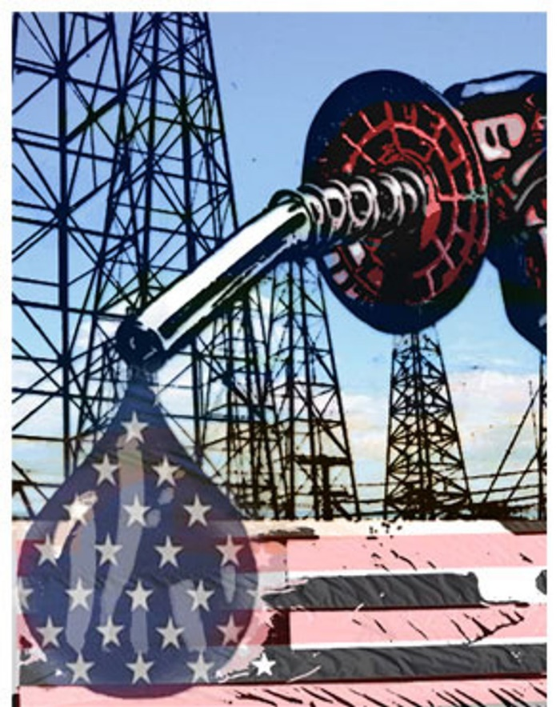

Photo from: Michael T. Klare, Oil: The real threat to national security (2004), https://perma.cc/T7T8-GNFU (last visited February 12, 2025).

Picture this: it’s a Monday morning and you are on the way to work, only to realize you forgot to fill up your car over the weekend, so you stop at your usual gas station. If you find yourself in the same spot as I do—and as do most Americans—you pay attention to one crucial marker when fueling up: the price you’re paying per gallon. After all, that number tangibly affects your daily life in a way that is worth noting. But what if I told you that the number isn’t the only factor you should be paying attention to?[1] The price of gas, and by extension, the global oil economy, is mired in geopolitical conflicts and compromises that dictate the state of the world in a way that goes far beyond each of our individual financial snapshots.[2]

In fact, energy independence is a key tenet of geopolitical stability.[3] A country cannot be a sovereign and stable nation when it’s dependent on another country for energy, no matter how much independent development that country has existing separately from its need for energy.[4] To strengthen national security, the U.S. must decrease its dependence on foreign energy sources and prioritize energy independence.[5] Dependence on foreign oil sources can jeopardize a country’s national security, as it relies on having stable and predictable access to energy for a nation’s infrastructure, military, and overall economy.[6] Ukraine’s reliance on Russian energy highlights the vulnerability of lacking energy independence, as Russia has used its control over energy as a geopolitical weapon, knowing that Ukraine and the EU generally are dependent on it for the functions vital to running a nation.[7] Similarly, the U.S. risks becoming vulnerable to pressure and manipulation from countries that control important energy resources.[8] By cutting back on foreign energy dependence, the U.S. can protect its sovereignty and maintain a stronger position on the world stage.[9] Energy independence also ensures that the military can function without interruption, especially during crises when access to fuel and power is critical for defense.[10] Boosting domestic energy production limits the ability of adversaries to disrupt or control vital energy supplies, making it an essential element of U.S. national security strategy.[11]

When energy is produced domestically, it’s not only the American energy worker or American company that benefits, but also regular, everyday Americans who benefit from affordable and stable sources of energy. The advantage is not just economic—it is ethical. By producing energy at home, the U.S. is not reliant on other countries whose leaders and energy producers may be engaged in morally questionable behavior.[12] Besides simply securing a stable supply of energy, energy independence will propel Americans’ autonomy and economic stability, while lessening vulnerabilities to geopolitical conflicts and disruptions in global energy markets.[13] True to American tradition, building a strong self-reliant energy system would create an environment that fosters innovation while strengthening national security[14]—and that’s a future I’d be incredibly proud to be a part of as an American.

Word count: 800

1. Jun, Wen, Xin-Xin, Zhao & Chun-Ping Chang, *The Impact of Extreme Events on Energy Price Risk*, Energy Economics 1, 2 (2021).
2. Ivan Aleksandrovich Kopytin, Alexander Oskarovich Maslennikov & Stanislav Vyacheslavovich Zhukov, *Europe in World Natural Gas Market: International Transmission of European Price Shocks*, International Journal of Energy Economics and Policy 8, 9 (2022).
3. *See generally* Andrian Prokip, *30 Years of Ukrainian Independence and Energy Dependence,* Focus Ukraine Blog (Sep. 7, 2021), https://perma.cc/8EVG-WK3Z (explaining how three decades of independent development Ukraine’s energy dependence on Russia has created a challenge to the country’s sovereignty and security in general).
4. *See* *id.* (affirming the idea of a lack of energy sufficiency as a challenge to sovereignty, how “three decades of independent development have not succeeded in fully loosening Ukraine’s ties to Russian energy).
5. *See generally* Surita Jayanti, *The World is Still Hooked on Russian Energy—at Its Own Peril*, Time (Oct. 20, 2024, 7:30 AM), <https://perma.cc/MZ2K-8UGJ> **(**describing how Ukraine’s dependence on Russian oil, has made it likely that many Ukrainians may die this winter from cold, hunger, or medical conditions that could have been treated if their hospitals had heating and electricity).
6. *Supra*, note 3.
7. Áron Dénes Hartvig, Bence Kiss-Dobronyi, Péter Kotek, Borbála Takácsné Tóth, Ioannis Gutzianas & András Zsombor Zareczky, *The Economic and Energy Security Implications of the Russian Energy Weapon*, Energy 1, 1 (2024).
8. *Infra*, note 11.
9. *Id.*
10. *See generally* David L. Bernhardt, *Energy Security is National Security*, The Washington Times (Sept. 9, 2019), <https://perma.cc/2H42-ASL8> (identifying the major reliance the U.S. has on foreign sources and supply chains).
11. *Id.*
12. *Id.*
13. *See generally* *Energy Independence and Security,* U.S. Department of Energy, <https://perma.cc/3WJJ-ZXZW> (explaininghow energy independence not only increases national security, but also will create more American jobs in the clean power sector and related industries, such as manufacturing, which will support U.S. economic growth and prosperity).
14. *Id.*