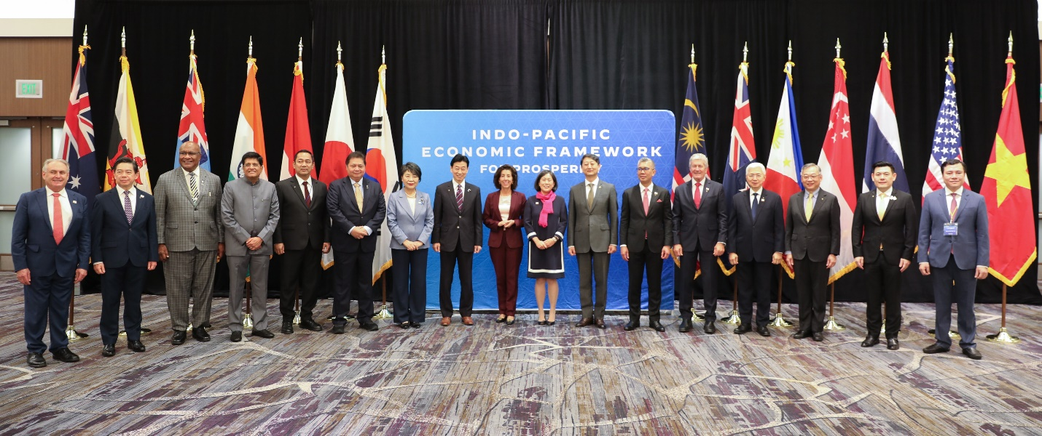
Indo-Pacific Economic Framework for Prosperity Agreement, Relating to a Fair Economy
Allison Semadeni
- Introduction.
The Indo-Pacific Economic Framework for Prosperity (IPEF) was launched by the United States in May of 2022. The IPEF consists of 14 partners including “Australia, Brunei Darussalam, Fiji, India, Indonesia, Japan, Republic of Korea, Malaysia, New Zealand, Philippines, Singapore, Thailand, the United States, and Viet Nam.” Since its creation, the IPEF has announced Pillar I: Fair and Resilient Trade, Pillar II: “the IPEF Agreement Relating to Supply Chain Resilience,” Pillar III: “the IPEF Agreement Relating to a Clean Economy,” and Pillar IV: “the IPEF Agreement Relating to a Fair Economy.” Each of these pillars reflects a different category of the larger purposes for economic prosperity. They have individually been rolled out over the last two years to attack particular areas of economic need. Additionally, a significant and overall purpose of this initiative is “to contribute to cooperation, stability, prosperity, development, and peace within the Indo-Pacific region.” The agreement is “not a trade agreement[] or a traditional trade agreement[,] [i]t’s an economic agreement.”
- The Fair Economy Agreement.
On June 6, 2024, in Singapore, the IPEF Agreement Relating to a Fair Economy (The Agreement) was opened for signature. All of the 14 partners, except for Viet Nam, signed The Agreement. On October 12, 2024, The Agreement entered into force. The Agreement’s initiatives are intended to “provide opportunities for interested IPEF partners to enhance their efforts to prevent and combat corruption including bribery, and support efforts to improve tax transparency and the exchange of information, domestic resource mobilization, and tax administration.”
The Agreement’s effective implementation was much more attainable due to the “critical role of technical assistance and capacity building (TACB).” The TACB “improve[s] transparency and predictability” and will be used to compile the initiatives into a Catalogue. This Catalogue “serves as an important resource upon the establishment of the Capacity Building Framework once the IPEF Fair Economy Agreement enters into force.”
Overall, The IPEF Agreement Relating to a Fair Economy, as Pillar IV of the IPEF, was created and entered into force with the goals including, but not limited to, sharing prosperity, “promoting labor rights,” ensuring free trade, and so much more. The Agreement has the potential to make a difference for the 14 partners, but with it comes potential future obstacles.
- Potential Future Problems and the Impact of the Fair Economy Agreement.
The future and the impact of the IPEF and the Agreement Relating to a Fair Economy rely on a number of factors and are likely to face challenges moving forward. The first of these factors and potential problems is the 2024 United States Presidential Election. Between Tuesday, November 5, 2024, and Wednesday, November 6, 2024, the Election results came in and Donald Trump became the next president-elect. As Donald Trump has previously shared, it is likely that during his second term, he will choose to withdraw the United States as a partner in the agreement. Given the United States’ role in the creation of the IPEF and Donald Trump's desire to pull out of the IPEF, it is likely that the United States’ 2024 election results will “affect IPEF negotiations, implementation, and impact.” The United States, as related to trade, is both an impactor and impacted by the IPEF and its potential removal from the IPEF and the Agreement would have major effects on imports and exports among all 14 partners. Overall, Donald Trump's previous indication of a desire to remove the U.S. from the IPEF could potentially have a tremendous impact not only on the implementation of Pillar IV, but the IPEF agreement as a whole for the rest of the partners.
Conversely, the more positive side of the impact of the Fair Economy Agreement is the potential for a higher level of standards, norms, and transparency to eliminate or mitigate corruption domestically and internationally. Evidence of this impact can be seen in the Australian government's analysis of the impact of the IPEF Fair Economy Agreement. In the analysis, the government shares that “the inclusion of commitments on beneficial ownership transparency in the Agreement will motivate IPEF countries to uplift their domestic regimes in line with international best practice, and ensure a more robust system for tackling corruption and financial crimes.” Furthermore, the IPEF provides the technical assistance and capacity to “enable an incentivize IPEF members to take a stronger stance on corruption, where they may otherwise have not had the resources and expertise to do so.” Along with so many other beneficial tools, the IPEF and Pillar IV, Relating to a Fair Economy, have the potential to significantly and positively impact the domestic and international economics of the 14 partners.
- Conclusion.
The Indo-Pacific Economic Framework for Prosperity Agreement was created to address economic areas of need among the fourteen partners. Each pillar of the agreement has and will continue to contribute to the economic prosperity in the Indo-Pacific Region. The introduction of Pillar IV, Relating to a Fair Economy, is set to have a great impact on the development of industry standards for anti-corruption. While the Fair Economy pillar of the IPEF is just beginning, the agreement is set to have a lasting impact on the development of each of the fourteen partners.

IPEF Timeline, U.S. Department of Commerce, https://www.commerce.gov/ipef/timeline [https://perma.cc/4F68-AEC6].
Office of Public Affairs, Press Statement on Indo-Pacific Economic Framework for Prosperity Ministerial Meeting in Singapore, U.S. Department of Commerce (June 18, 1991), https://sg.usembassy.gov/press-statement-on-indo-pacific-economic-framework-for-prosperity-ministerial-meeting-in-singapore/ [https://perma.cc/J2SG-2U5R].
Pillar I – Fair and Resilient Trade, U.S. Department of Commerce, https://www.commerce.gov/ipef/pillar-i [https://perma.cc/G4AF-DFFF].
Office of Public Affairs, supra note 2.
Current Affairs, 3 Ministerial Meeting of Indo-Pacific Economic Framework for Prosperity, Khan Global Studies, https://currentaffairs.khanglobalstudies.com/3rd-ministerial-meeting-of-indo-pacific-economic-framework-for-prosperity/ [https://perma.cc/23SX-YXH8].
Chad P. Bown and Barbara Weisel, What is the Indo-Pacific Economic Framework and Will it Work?, Peterson Institute for International Economics (Dec. 12, 2022), https://www.piie.com/blogs/realtime-economics/what-indo-pacific-economic-framework-and-will-it-work [https://perma.cc/AJN2-VA6A] (Excerpts from the Trade Talks Podcast).
IPEF Fair Economy Agreement, U.S. Department of State 1, 1 (2024), https://www.state.gov/wp-content/uploads/2024/10/IPEF-Fair-Economy-Agreement.pdf [https://perma.cc/N7X2-FGUJ].
See id.
Office of Treaty Affairs, 6. Indo-Pacific economic Framework for Prosperity Agreement Relating to a Fair Economy, Done at Singapore, U.S. Department of State (June 6, 2024), https://www.state.gov/ipef-fair-economy-agreement [https://perma.cc/C3KG-XHGH].
Office of Public Affairs, supra note 2. See Indo-Pacific Economic Framework For Prosperity Agreement Relating to a Fair Economy art. 1, ¶ 1, June 6, 2024, https://www.commerce.gov/sites/default/files/2024-03/IPEF-PIV-Fair-Economy-Agreement.pdf [https://perma.cc/2KHZ-H7TB].
U.S. Embassy Singapore, Press Statement on Indo-Pacific Economic Framework for Prosperity Ministerial Meeting in Singapore, U.S. Embassy in Singapore (June 6, 2024), https://sg.usembassy.gov/press-statement-on-indo-pacific-economic-framework-for-prosperity-ministerial-meeting-in-singapore/ [https://perma.cc/J2SG-2U5R].
Id.
Id.
Indo-Pacific Economic Framework For Prosperity Agreement Relating to a Fair Economy, supra note 10 (Introduction to Treaty on pages 1 and 2).
See Nathan Layne, Trump Vows to Kill Asia Trade Deal Being Pursued by Biden if Elected, Reuters (Nov. 18, 2023), https://www.reuters.com/world/us/trump-vows-kill-asia-trade-deal-being-pursued-by-biden-if-elected-2023-11-19/ [https://perma.cc/U6R9-JJMV].
See IPEF Timeline, supra note 1.
See Layne, supra note 15.
Cathleen D. Cimino-Isaacs et al., Indo-Pacific Economic Framework for Prosperity (IPEF), Congressional Research Service 1, 2 (2024), https://crsreports.congress.gov/product/pdf/IF/IF12373#:~:text=U.S.%2DIPEF%20Partner%20Trade%20Ties&text=IPEF%20partners%20accounted%20for%20nearly,investment%20in%20the%20United%20States [https://perma.cc/5P3C-SE8Q].
See id. at 1.
Department of Foreign Affairs and Trade, IPEF Fair Economy Agreement Policy Impact Analysis, Australian Government 1, 20-22, https://www.aph.gov.au/-/media/02_Parliamentary_Business/24_Committees/244_Joint_Committees/JSCT/2024/IPEF_Fair_Economy/PIA.pdf?la=en&hash=6940124AB3FC2BCAB0CBB7F961D67D41FEF0F2AB [https://perma.cc/G7W5-65D7].
Id. at 21.
Id. at 22.

