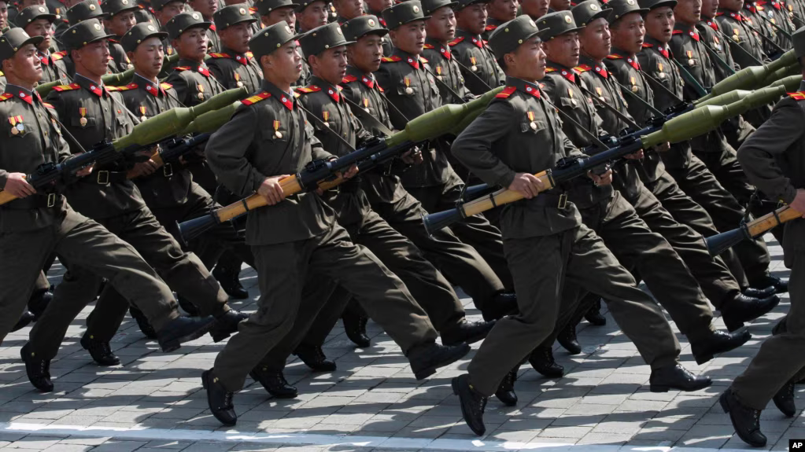

North Korean soldiers march during a military parade in Pyongyang (photograph), in RFE/RL's Ukrainian Service & Current Time, Russia To Send North Korean Troops Into Battle Within Days, Zelenskiy Warns (Oct. 25, 2024), https://www.rferl.org/a/ukraine-north-korea-troops-zelenskiy-russia-battle/33172774.html [https://perma.cc/D2TK-WDKB].

North Korea's Military Support to Russia: Implications for Global Stability
and International Law
Nate Nys

As the war between Russia and Ukraine rages on, media outlets and government officials have recently presented convincing evidence that North Korea has provided Russia with military troops. While North Korea and Russia have regularly exchanged various arms and munitions, Kim Jong Un’s decision to send members of the North Korean armed forces to Russia is unprecedented and may cause the International Criminal Court (ICC) to issue an order for Kim Jong Un’s arrest.
The United Nations created the ICC to facilitate cooperation between member states “to investigate, prosecute and try individuals accused of committing the most serious crimes of concern to the international community as a whole: the crime of genocide, crimes against humanity, war crimes, and the crime of aggression.” The ICC permits law enforcement in any given member state to arrest individuals charged by the ICC with violating international law.
The ICC has already issued an arrest warrant for Vladimir Putin because the Court alleges that there are reasonable grounds to believe that he engaged in the unlawful deportation of children from occupied areas of Ukraine to Russia. If Putin is ultimately convicted for his actions in Ukraine, Kim Jong Un may also face the prospect of being arrested and subsequently charged by the ICC for violating Article 25(3) of the Rome Statute.
Article 25(3) maintains that individuals who assist others in committing “crimes of aggression” can be charged as accomplices by the ICC. Article 8(2)(g) defines “[t]he sending by or on behalf of a State of armed bands, groups, irregulars, or mercenaries, which carry out acts of armed forces against another State” as a “crime of aggression.” Thus, any direct military engagements between North Korean and Ukrainian troops may provide the ICC with a sufficient basis to charge Kim Jong Un with violating international law.
The accusation that North Korea broke international law likely comes as no surprise; the pariah state has repeatedly tried to evade sanctions and is engaging in the proliferation of weapons of mass destruction. While the ICC has not yet charged Kim Jong Un with breaking international law, engaging in direct military confrontations with signatory countries may be enough to persuade the ICC to issue a warrant for Kim Jong Un’s arrest.
The threat of the ICC being able to actually arrest Kim Jong Un may be hollow, as he rarely leaves North Korea. When he does leave the country, he does not travel to countries that are signatories of the ICC. However, given the international tension caused by the war in Ukraine, such an act could provoke members of the ICC to respond by providing Ukraine with more arms and potentially foreign troops. As such, the war in Ukraine may escalate to a global conflict, where numerous countries are forced to choose between supporting one of the two nations. The stability of the international order may hang in the balance.

See Hyung-Jin Kim et al., US Confirms North Korea Has Sent 3,000 Troops to Russia for Training and Possible Ukraine Combat, Associated Press (Oct. 23, 2024), https://abcnews.go.com/International/wireStory/lawmakers-south-koreas-spy-chief-north-korea-1500-115055865 [https://perma.cc/S262-MV9Q].
See Ulyana Krychkovska & Ivan Diakonov, Zelenskyy Responds on Whether Ukraine Could Request ICC Arrest Warrant for Kim Jong Un, Ukrainska Pravda (Oct. 31, 2024), https://www.pravda.com.ua/eng/news/2024/10/31/7482364/ [https://perma.cc/UL7J-K5E9].
International Criminal Court [ICC], What is the ICC and What Does it Do?, https://www.icc-cpi.int/sites/default/files/lesson1.pdf [https://perma.cc/QA4T-LPYX].
Id.
Sang-jung Byun, Referring Kim Jong Un to the ICC as an ‘Accomplice to War Crimes’: Review of International Jurisprudence, Issue Brief, 2024, at 1, 5.
Id. at 1-2.
Rome Statute of the International Criminal Court art. 25(3), July 17, 1998, 2187 U.N.T.S. 90.
Id. art. 8(2)(g).
See Byun, supra note 5, at 5-6.
See Shreyas Reddy, et. al., Boats, Planes and Armoured Train: How Kim Jong Un Travels Abroad, BBC (Sep. 11, 2023), https://www.bbc.com/news/world-asia-44054024 [https://perma.cc/M3S3-CHNV].
See id.
See Sarah Shamim, North Korean Troops in Russia: How Will it Impact the Ukraine War?, Al Jazeera (Oct. 29, 2024), https://www.aljazeera.com/news/2024/10/29/north-korean-troops-in-russia-how-will-it-impact-the-ukraine-war [https://perma.cc/3FZN-WM8X].

