The International Code for the Protection of Tourists: A Potential Solution to the Crisis in Barcelona, Spain

Allison Semadeni

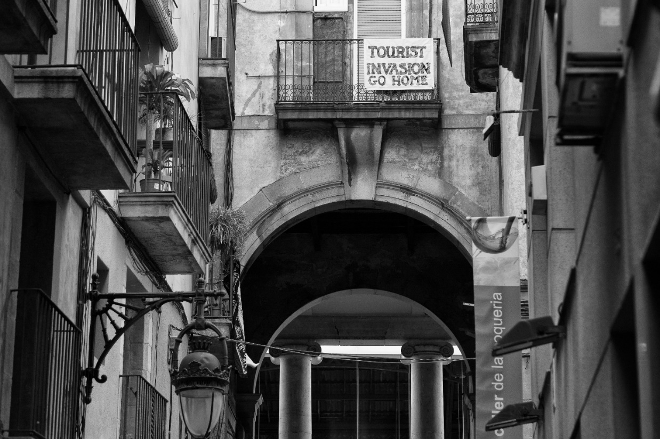

The recovery of tourism during post COVID-19 has been a remarkable testament to the importance of global connection and travel. As vaccination rates increased and traveling became more accessible, the world saw a resurgence in tourism. With the slowing down of COVID-19 and a new revival of tourism, the need for new regulations, statutes, and policies adapted to this age was and is great. In 2021, the General Assembly of the World Tourism Organization saw this need and adopted a new resolution, 732 (XXIV), to create the International Code for the Protection of Tourists (The Code). The Code has had a strong impact on the revival and continuance of tourism and, because of Chapter Four (“International Settlement of Travel and Tourism Disputes Via Alternative Means of Dispute Resolution”) and Chapter Five (“Mechanisms for Adherence to and the Application of the Recommendations of the International Code for the Protection of Tourists”), it may have a great impact and improvement on the distress and protests surrounding tourism in Barcelona, Spain.
An Introduction to The International Code for the Protection of Tourists
The Code “was formally adopted at the 24th UNWTO General Assembly” in December of 2021. “As a fundamental frame of reference for the recovery in post COVID-19 era,” the Code “provides a set of minimum international standards for the protection of tourists in emergency situations and consumer rights of tourists.” The Code is composed of five chapters: definitions, addressing international assistance to tourists in emergency situations, tourists’ protection in contracts, the settlement of travel and tourism disputes, and recommendations for adherence to and application of The Code.
Chapters Four and Five of The Code are of significant interest in the context of the current issues in Barcelona, Spain, discussed in the next section. Chapter Four focuses on the “International Settlement of Travel and Tourism Disputes via Alternative Means of Dispute Resolution.” The purpose of Chapter Four “is to foster the development and application of” alternative and online dispute resolution mechanisms (ADR and ODR respectively). There is one relevant section of Chapter Four (Section B) when discussing the implications of the application of The Code, which will be examined further in the next two sections. Section B focuses on “compris[ing] a set of recommendations for ADR/ODR and amicable mechanisms addressed to countries with a view to guiding them in dealing with consumers.” The Second relevant chapter is Chapter Five, which focuses on “Mechanisms for Adherence to and the Application of the Recommendation of the International Code for the Protection of Tourists.” There is one relevant section of Chapter Five (Section B) when discussing the implications of the application of The Code, which will be examined further in the next two sections. Section B focuses on “[r]elationships with national law and international agreements,” Section C focuses on “[m]onitoring and reporting,” and Section D focuses on “[e]valuation and interpretation.”
Since the Code’s initial adoption, nineteen nations have fully adhered to the Code and five nations have partially adhered to the Code. These members include Paraguay, Portugal, Guatemala, Argentina, etc. Two of the most recent members are Cuba, which adhered on April 29, 2024, and the United Arab Emirates, which adhered on June 26, 2024.
Occasionally, Conferences will be held to “address the gaps in existing legal frameworks and disparities between countries in terms of the protection of tourists in emergency situations” as well as to “share experiences and best practices among countries for rebuilding trust in tourism.” In addition to the purpose of the Conferences, UNWTO stated that the “Conference will address issues such as … [w]hat benefits do adherence to the Code offer to Member States?” Questions like this are essential to the understanding of both the implementation and impact of the Code on both current nations adhering to the Code and potential future nations that could benefit from the Code.
How The Code Has Been Implemented and the Impact of The Code’s Implementation
In recent years, especially in the post COVID-19 era, tourism has grown at an exponential rate. This “touristification process of places has … been laying the grounds for what is known as overtourism, which … is not about only the excessive number of visitors in a certain place in a certain moment, but rather the cause of much deeper consequences.” “Pressure, congestion and overcrowding at sites of high tourist interest are only the tip of the iceberg,” and can cause further problems which “hide[] different manifestations and inequalities and asymmetrical power relations, very often affecting the most vulnerable in the community.”
The problems created by overtourism were and are intended to be addressed in part by The Code. As “the first ever legal instrument designed to create internationally recognized standards for the protection of tourists,” The Code “provided a platform for regional tourism leaders to share insights, best practices[,] and lessons learn[ed] on how this legal tool supports tourism recovery and trust.” Furthermore, “The Code provides greater legal clarity to States through a common and harmonized framework on how to assist tourists in emergency situations and help them develop laws, regulations[,] and policies for the protection of tourists as consumers.”
On a more granular level, Chapter Four, Section B, Subsection Number One of The Code provides for an “available effect dispute resolution” method, which is “inexpensive” and a potentially helpful way to resolve various conflicts that arise from overtourism. Additionally, in Chapter Four, Section B, Subsection Number Ten of the Code states that it intends to “foster international enforcement, cooperation, and information sharing among Member States” and to “coordinat[e] among enforcement agencies to prevent harmful practices and drive improvements which help international tourists in travel and tourism disputes.” Chapter Five, Section B, Subsection Number One of The Code states that it is “intended to provide guidance to Governments as to proposed policy, legislation and regulatory practice at the national level.” Each of the examples of specific textual portions of The Code illustrates the intent of The Code, the resources of The Code, and the need for The Code. The examples, among many other portions of The Code, can provide a real change in the current conflicts from overtourism.
How the Code Would Potentially Impact the Current Unrest in Barcelona, Spain
Following the post COVID-19 era and the correlating drive for tourism went into full swing, Barcelona, Spain, saw increased demonstrations against mass tourism. Most recently, “[i]n early July, protesters marched through popular tourist areas in the Spanish city of Barcelona spraying unsuspecting visitors with water pistols while chanting ‘tourists go home’.” The protests are in reaction to more than tourism itself, but rather “the growing issue of rising rents and house prices, which has made home ownership almost impossible for some residents.” Residents of Barcelona, Spain are placing the blame for these issues “on one thing: mass tourism.”
While there is a call against this mass tourism, residents recognize that the real issue is the management of tourism. Residents are putting pressure on the government to change policies that affect tourism; stating that “the main issues at play here are structural, not personal.” Tourism is important to Barcelona, but it needs adjusting. Tourism plays a big economic role in the city, accounting for 14% of GDP, employing “about 150,000 people[,] and generat[ing] almost €12.75bn annually.” It also impacts the city’s character by “attract[ing] more drug trafficking, petty crime[,] and sex work.”
One policy that can be assessed as a valid tool in the conversation about changing the tourism structure in Barcelona is The Code. There are a couple of benefits that are noteworthy to Barcelona’s current situation. The first is that Portugal, one of Spain’s neighboring countries, has been implementing The Code since its adherence date on April 22, 2022. Having a neighboring company can be useful in implementing a code that focuses on the coordination of information and expertise between the member states. Secondly, information dispersion and conversations have already occurred in the country of Spain. Between November 30th and December 1st of 2023, “[t]he first seminar on the International Code for the Protection of Tourists” was “held in Salamanca.” The seminar “brought together legal experts, academics and representatives of the public and private sector to address the achievements of the Code … and to assess the challenges ahead in the coming years.” This seminar gave a front-seat view for Spain to understand The Code’s benefits, challenges, and opportunities, and share input when the key challenges were addressed. Access to knowledge for Spain via the seminar is a key reason why The Code would be a great tool when approaching Barcelona’s situation.
Finally, Chapter Four and Chapter Five are two parts of The Code that apply to the current situation in Barcelona. It is first important to note that adherence to The Code can be complete or partial and is completely voluntary. Thus, if Barcelona were to implement The Code, adherence can be stipulated based on need. Chapter Four, Section B, Subsections Number One, Three, Seven, and Eight are a couple of sections that may apply well in Barcelona. These subsections could create dispute-resolution avenues with various accessible schemes that would have low costs and produce expedited solutions. Additionally, the dispute-resolution avenues could resolve conflicts with solutions that are better for both parties (Barcelona and Tourists).
Furthermore, Chapter Five, Section B, Subsection Number One would be of particular interest in Barcelona’s situation. The Code is a starting point for solving Barcelona’s problems, as it goes beyond tourism. However, by adhering to “the non-legally binding instrument intended to provide guidance to governments,” The Code can become a stepping stone in the development of legally-binding policies, legislations, and regulations, which address not only tourism in the city, but also the financial, housing, and cultural crisis.
In conclusion, The International Code for the Protection of Tourists is an impactful code in the post COVID-19 era. The Code has been a source of structure for adhering countries in dealing with emergency situations, the pressures of overtourism, and the adjudication of disputes and discrepancies between the nation and the tourists. In regard to the ongoing vulnerabilities in Barcelona, Spain, The Code could have a potentially positive impact on the city and beyond for three primary reasons: Portugal, a neighboring country, has been adhering to The Code, Spain has been exposed to important information and conversations regarding The Code, and certain portions of The Code, such as Chapter Four and Five, would have a tremendous impact in Barcelona. While the Code’s adhering countries are primarily located in Central and South America, the expansion of the Code to places such as Barcelona, Spain, and beyond could positively support the growing tourism and mitigate its negative impacts around the world in the years to come.

UN Tourism, Int’l Code for the Prot. of Tourists, https://www.unwto.org/international-code-for-the-protection-of-tourists [https://perma.cc/2EYJ-2XQX] (last visited Sept. 10, 2024).
UNWTO, Int’l Code for the Prot. of Tourists, World Tourism Organization 2, 2 (2022), https://pre-webunwto.s3.eu-west-1.amazonaws.com/s3fs-public/2024-05/2022-international-code-for-the-protection-of-touristso.pdf?VersionId=a_D9MtLvZU6skrFbT7_j7d2bl.XrE_pq [https://perma.cc/GZ6G-D2S8].
UN Tourism, Asia and Pac. Unite in Support of the Int’l Code for the Prot. Of Tourists, https://www.unwto.org/news/asia-and-pacific-unite-in-support-of-the-international-code-for-the-protection-of-tourists#:~:text=The%20%22Phnom%20Penh%20Declaration%20on,Ministry%20of%20Tourism%20of%20Cambodia [https://perma.cc/URS5-UA9A] (last visited Sept. 10, 2024).
UN Tourism, supra note 1.
See UNWTO, supra note 2.
Id.
Id. at 35.
Id.
Id. at 40.
Id. at 41-43.
See UN Tourism, Adherence to the Int’l Code for the Prot. of Tourists and Subsequent Steps, https://www.unwto.org/adherence-to-the-international-code-for-the-protection-of-tourists#countries [https://perma.cc/7R9A-558W] (last visited Sept. 10, 2024).
Id.
Id.
UNWTO, UNWTO Conf. on the Int’l Code for the Prot. of Tourists, UNWTO Concept Notes 1, 2 (2023), https://webunwto.s3.eu-west-1.amazonaws.com/s3fs-public/2023-05/Concept%20Note_UNWTO%20Conference%20on%20the%20ICPT_Final.pdf?VersionId=JhL1Yd8.XC3R8aMDkoV7Y83xWs7Ad1MG [https://perma.cc/KSD6-4XDN].
Id. at 3.
Claudio Milano, Marina Novelli, and Antonio Paolo Russo, Anti-tourism activism and the inconvenient truths about mass tourism, touristification and overtourism, Tourism Geographies, An Int’l J. of Tourism Space, Place and Env’t 1, 3 (2024), https://www.tandfonline.com/doi/pdf/10.1080/14616688.2024.2391388.
Id.
UN Tourism, Asia and Pac. Unite in Support of the Int’l Code for the Prot. Of Tourists, https://www.unwto.org/news/asia-and-pacific-unite-in-support-of-the-international-code-for-the-protection-of-tourists#:~:text=The%20%22Phnom%20Penh%20Declaration%20on,Ministry%20of%20Tourism%20of%20Cambodia [https://perma.cc/URS5-UA9A] (last visited Sept. 10, 2024).
Id.
UNWTO, supra note 2, at 36.
Id. at 38.
Id. at 41.
Billy Stockwell, ‘A point of no return:’ Why Eur. has become an epicenter for anti-tourism protests this summer, https://www.cnn.com/2024/07/27/travel/why-europe-has-become-an-epicenter-for-anti-tourism-protests-this-summer/index.html [https://perma.cc/6T7E-JHEW] (last visited Sept. 10, 2024).
Id.
Id.
Id.
Id.
Xavier Mas de Xaxàs, My Barcelona is being destroyed by mass tourism – but kicking visitors out isn’t the answer, https://www.theguardian.com/commentisfree/article/2024/aug/19/barcelona-mass-tourism-visitors-city-industry [https://perma.cc/LU36-TL4D] (last visited Sept. 10, 2024).
Id.
UN Tourism, supra note 11.
See UNWTO, supra note 2, at 38.
See The Diplomat, Legal Experts Discuss the UNWTO Code for the Prot. of Tourists, https://thediplomatinspain.com/en/2023/12/19/legal-experts-discuss-the-unwto-code-for-the-protection-of-tourists/81818/#:~:text=As%20well%20as%20addressing%20the%20key%20challenges%20standing%20in%20the [https://perma.cc/T8W9-DWQ3] (last visited Oct. 7, 2024).
Id.
Id.
See UNWTO, supra note 2, at 41.
Id. at 37.
See id.
Id. at 41.

