The United Nations Children’s Fund’s (UNICEF) Role in Addressing the Prevention of Child Soldier Recruitment

Oluwafikemi Fawehinmi
University of North Carolina School of Law
Report Fall 2024

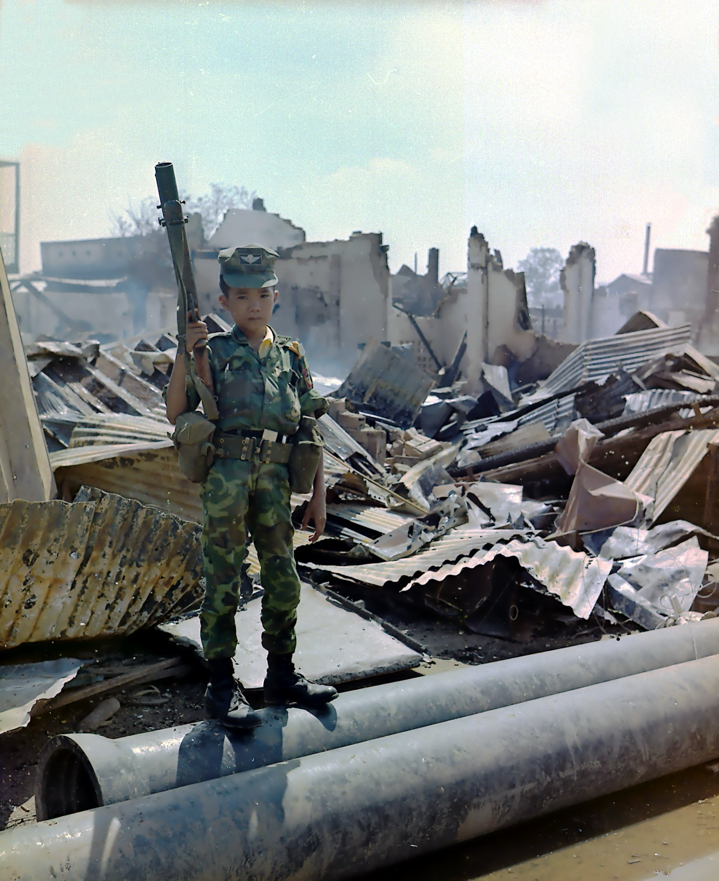

- Introduction

The United Nations Children’s Fund (UNICEF) is an international organization that promotes children’s rights. Having an impact in “more than 190 countries and territories,” UNICEF strives to overcome challenges - including violence - in the lives of children. The Agency’s focus areas include: “(1) child survival and development; (2) basic education and gender equality; (3) HIV/AIDS and children; (4) child protection; [and] (5) policy advocacy and partnerships.” Having an organization like UNICEF in the world we live in today - where children are constantly being abused and stripped of their rights - is crucial. However, it is even more important that UNICEF steps in appropriately, when needed.
An area that presently needs UNICEF’s undivided attention is the recruitment and use of child soldiers in armed conflict. According to the United Nations’ Paris Principles on the Involvement of Children in Armed Conflict (Paris Principles), a child “associated with an armed force or armed group” is essentially “any person below 18 years of age who is or had been recruited or used by an armed force or armed group in any capacity . . . .”
This report will address the inadequacy of UNICEF’s current mechanisms to prevent the recruitment of children as soldiers. It is undisputed that UNICEF has taken substantial steps to prevent the recruitment and use of children in armed conflict, demonstrated by agency campaigns such as “Children, Not Soldiers”. Additionally, the UN General Assembly adopted the “Optional Protocol to the Convention on the Rights of the Child on the Involvement of Children in Armed Conflict”. However, when compared to the level of importance the organization places on areas like counterterrorism and other war crimes, its efforts are simply insufficient.
- Child Soldiers
Children around the world in countries like Somalia, Syria, the Democratic Republic of Congo, and Yemen are abducted into submission to join armed forces. Some children join military groups to flee from poverty, protect their communities, seek revenge, “with promises of money or other incentives,” or for other personal motivations. These children are forced to face many types of armed forces including professional western forces. Almost “80 percent of conflicts involving child soldiers include combatants [under] the age of fifteen, with some as young as seven or eight.” An estimated 300,000 children are fighting in around thirty conflicts across the globe. "In 2019 alone, more than 7,740 children, some as young as six, were recruited and used as soldiers around the world.”
Impacted children are not exclusively used in combat, rather they can also serve in support roles, including as “cooks, spies, messengers, and even sex slaves." A troubling aspect of modern warfare is the growing use of children as suicide bombers. Since children are “easier to manipulate” and are “less likely to arouse suspicion,” armed groups, including the Taliban, use children to carry out these bombs. From 2014 to 2021, “suicide attacks by Taliban forces [resulted in around] 6,000 civilian casualties.”
The effects of these experiences affect the children in many ways, including “caus[ing] long-term trauma that can disrupt their psychological and moral development and hamper wider social development for years ahead.” It can also leave them with “disabilities for the rest of their lives.” “Warring parties also [deny] children proper nutrition and healthy living conditions, or [expose] them to substance abuse,” leading to serious impacts on “their physical and mental health.”
- Actions UNICEF Has Taken to Prevent the Recruitment and Use of Child Soldiers
UNICEF has taken notable steps to prevent the recruitment and use of child soldiers. In response to violence against children, the organization collaborates “with governments, community groups, and other” stakeholders to address the root causes “of child recruitment and stop violations before they [happen].” It has established programs that connect “children and families to mental and physical health services, education, catch-up classes, and vocational” training. Additionally, UNICEF “supports the release and reintegration of thousands of children [leaving these] armed forces and groups each year,” offering safe housing, “case management, family tracing, reunification, and psychological support.” Specialized assistance is also provided to “survivors of gender-based violence.” UNICEF has issued a global call to uphold children's rights in conflict, hold violators accountable, ensure the safety of children and their communities, support recovery from war, and promote inclusive and lasting peace.
While UNICEF has indeed taken meaningful actions, their efforts have not been enough. Despite their initiatives, countless children around the world remain trapped as child soldiers, enduring unimaginable horrors. The attention and resources UNICEF dedicates to this issue fall short, especially when compared to the focus it places on other matters, such as counter-terrorism. Ironically, counter-terrorism operations often result in crimes against child soldiers who are viewed not as victims, but as perpetrators of extreme violence. In this context, UNICEF’s efforts are insufficient, and more must be done to prioritize and address the urgent plight of child soldiers. UNICEF plays a vital role in addressing international war crimes, and their limited action speaks volumes. If they don’t take meaningful steps, who will?
- Actions UNICEF Should Take to Further Prevent the Recruitment and Use of Child Soldiers
To make a more meaningful impact on the lives of child soldiers and children at risk of recruitment, UNICEF should take additional steps beyond its current efforts – culturally legitimate steps. One vital initiative would be the creation of an office for a special rapporteur focused solely on the issue of child soldiers, as it has done for the issue of counter-terrorism. This specialized position could ensure that the issue remains a priority on the global stage, driving focused attention and action from international organizations, governments, and other stakeholders.
Moreover, UNICEF can further expand its collaboration with community-based organizations to create grassroots solutions for preventing child soldier recruitment. There is a “need to engage in grassroots campaigns for successful harmonization of treaty norms and local values.” These organizations will be uniquely positioned to engage with local populations, address the socioeconomic factors that contribute to child soldiering, and provide early warnings of recruitment activity. Strengthening advocacy, policy influence, and legal frameworks among all relevant stakeholders is also essential, and relates to grassroots regional campaigns. “Regional complaints mechanisms would also help build a regional consensus on children's rights norm.” Additionally, allowing these NGOs to bring legal action before national and regional courts will improve access to the justice systems.”
Finally, creating and implementing productive reintegration programs with thorough monitoring, evaluation, and sustainability mechanisms will help ensure that former child soldiers can successfully reintegrate into society, providing long-term support and stability. “Development aid can [] be used directly to mitigate conflict or build programs that focus on reintegrating child soldiers or rehabilitating agricultural capacities.” By adopting these measures, UNICEF can potentially enhance its effectiveness in combatting this critical issue.
- Conclusion
While UNICEF has made commendable strides in addressing the recruitment and use of child soldiers, its current efforts remain insufficient given the scale of the issue. Despite the significant steps taken to support the reintegration and recovery of former child soldiers, countless children continue to endure exploitation in armed conflicts worldwide. To effectively combat this issue, UNICEF must elevate the urgency of this crisis by allocating more resources, increasing advocacy, and creating specialized programs dedicated to preventing child soldier recruitment. Only by intensifying its focus on this dire issue can UNICEF truly fulfill its mission of safeguarding children's rights and well-being globally.

https://live.staticflickr.com/7421/14013513226_ae53279d59_b.jpg
See UNICEF: The United Nations Children’s Fund, United Nations, https://www.un.org/youthenvoy/2013/09/unicef-the-united-nations-childrens-fund/#:~:text=UNICEF%20is%20the%20driving%20force,most%20innovative%20ideas%20into%20reality [https://perma.cc/6REP-LXQD] (providing an overview of UNICEF includings its mission and impact).
Id.
Id.
See generally id. (providing an overview of UNICEF includings its mission and impact).
UN Children’s Fund (UNICEF), The Paris Principles. Principles and Guidelines on Children Assoiated With Armed Forces or Armed Groups 7 (2007).
See generally Child Recruitment and Use, Off. of Special Represntative of Sec’y Gen. for Child. and Armed Conflict, https://childrenandarmedconflict.un.org/six-grave-violations/child-soldiers/#:~:text= [PERMA LINK – Was unable to create one for this site – I contacted the Law Library] [hereinafter Child Recruitment].
Id.
Emeline Wuilbercq, Ten Facts About Child Soldiers Around the World, Reuters (2021), https://www.reuters.com/article/world/factbox-ten-facts-about-child-soldiers-around-the-world-idUSKBN2AC0CB/#:~:text=The%20Democratic%20Republic%20of%20Congo%2C%20Somalia%2C%20Syria%20and%20Yemen%20currently,as%20domestic%20or%20sexual%20slaves [PERMA LINK – Was unable to create one for this site].
Jo Becker, This is Our Opportunity to End the Taliban’s Use of Child Soldiers, Human Rights Watch (Sept. 20, 2021, 10:00 AM), https://www.hrw.org/news/2021/09/20/our-opportunity-end-talibans-use-child-soldiers#:~:text=For%20more%20than%20two%20decades,remain%20in%20their%20ranks%20today [https://perma.cc/68MM-ZSDS]; see Child Recruitment, supra note 7.
Roos Haer, Children and Armed Conflict: Looking at the Future and Learning From the Past, Taylor and Francis Group (2019), https://www.tandfonline.com/doi/epdf/10.1080/01436597.2018.1552131?needAccess=true [PERMA LINK – Was unable to create one for this site]; P W Singer, Western Militaries Confront Child Soldiers Threat, Jane’s Intelligence Review (2005), https://www.brookings.edu/wp-content/uploads/2016/06/singer20050115.pdf [https://perma.cc/EZ9J-HQ2P].
Eben Kaplan, Child Soldiers Around the World, Council on Foreign Relations (2005), https://www.cfr.org/backgrounder/child-soldiers-around-world [https://perma.cc/NJR9-MWPH]
Id.
Wuilbercq, supra note 9.
Child Recruitment, supra note 7.
Child Recruitment, supra note 7.
Becker, supra note 10.
Becker, supra note 10.
Peter W. Singer, Western Militaries Confront Child Soliders Threat, 17 Jane’s Intel. Rev., Jan. 1, 2005, at 1, 2.
Child Recruitment, supra note 7.
Children Recruited by Armed Forces or Armed Groups, UNICEF, (Dec. 22, 2021), https://www.unicef.org/protection/children-recruited-by-armed-forces [PERMA LINK – Was unable to create one for this site – I contacted the Law Library].
See UNICEF: Children, Not Soldiers, United Nations, https://www.unicef.org/mena/press-releases/children-not-soldiers [PERMA LINK – Was unable to create one for this site – I contacted the Law Library].-yemen#:~:text=In%20March%202014%2C%20the%20Special,in%20conflict%2C”%20said%20Ms [PERMA LINK – Was unable to create one for this site – I contacted the Law Library]. .; UNICEF: UNICEF is Working to Free Child Soldiers Around the World, United Nations, https://www.unicefusa.org/stories/unicef-working-free-child-soldiers-around-world [PERMA LINK – Was unable to create one for this site – I contacted the Law Library].
Children Recruited by Armed Forces or Armed Groups, UNICEF, (Dec. 22, 2021), https://www.unicef.org/protection/children-recruited-by-armed-forces [PERMA LINK – Was unable to create one for this site – I contacted the Law Library].
Id.
Id.
Id.
UNICEF’s Change Agenda for Protecting Children in Armed Conflict, UNICEF, https://www.unicef.org/children-under-attack/change-agenda [PERMA LINK – Was unable to create one for this site – I contacted the Law Library].
Children: Impact of International Conflict, Hansard, (Sept. 12, 2024), https://hansard.parliament.uk/Lords/2024-09-12/debates/E7D9561D-F49F-43DD-825B-1BB731141957/ChildrenImpactOfInternationalConflict [PERMA LINK – Was unable to create one for this site].
See UNICEF: Countering Terrorism, United Nations, https://www.un.org/en/global-issues/countering-terrorism#:~:text=The%20United%20Nations%20Office%20of%20Counter%2DTerrorism%20(UNOCT)%20works,strengthens%20coordination%20among%20UN%20entities [https://perma.cc/6Z52-F73V].
Sandra Krähenmann & Paulien Vandendriessche, From Child Soldier to Child ‘Terrorist’: Safeguarding Innocence from Counter-Terrorism, Humanitarian L. & Pol’y (Nov. 20, 2019), https://blogs.icrc.org/law-and-policy/2019/11/20/child-soldier-counter-terrorism/ [https://perma.cc/UR7N-M2PS].
Mary Rumsey, The Convention on the Rights of the Child: A Cultural Legitimacy Critique. by Thoko Kaime. Groningen: Europa Law Publishing, 2011. Pp. v, 216. Isbn: 978-90-8952-113-2. é48.00; Us$75.00, 41 Int'l J. Legal Info. 397 (2013)
UNICEF, supra note 29.
United Nations Human Rights, Special Rapporteur on Counter-Terrorism and Human Rights, United Nations, https://www.ohchr.org/en/special-procedures/sr-terrorism [PERMA LINK – Was unable to create one for this site].
Protecting the World's Children: Impact of the Convention on the Rights of the Child in Diverse Legal Systems. by Savitri Gooneskere, Rebeca Rios-Kohn, Emilio Garcia Mendez, and Shaheen Sardar Ali.cambridge, U.K.; New Yo, 40 Int'l J. Legal Info. 320, 324 (2012)
Id.
Id.; Mary Rumsey, The Convention on the Rights of the Child: A Cultural Legitimacy Critique. by Thoko Kaime. Groningen: Europa Law Publishing, 2011. Pp. v, 216. Isbn: 978-90-8952-113-2. é48.00; Us$75.00, 41 Int'l J. Legal Info. 397, 399 (2013); Corrine Parver, Esq. & Rebecca Wolf, Civil Society's Involvement in Post-Conflict Peacebuilding, 36 Int'l J. Legal Info. 51, 70 (2008)
Id.
Id.
Corrine Parver, Esq. & Rebecca Wolf, Civil Society's Involvement in Post-Conflict Peacebuilding, 36 Int'l J. Legal Info. 51, 69 (2008)
Id.
Christopher M. Faulkner, Why Child Soldiering Persists in Africa, Geo. J. of Int’l. Aff. (2024), https://gjia.georgetown.edu/2024/02/25/why-child-soldiering-persists-in-africa/ [https://perma.cc/YRP6-QBKX].
Id.

