**The Uyghurs: A Genocide Unanswered**

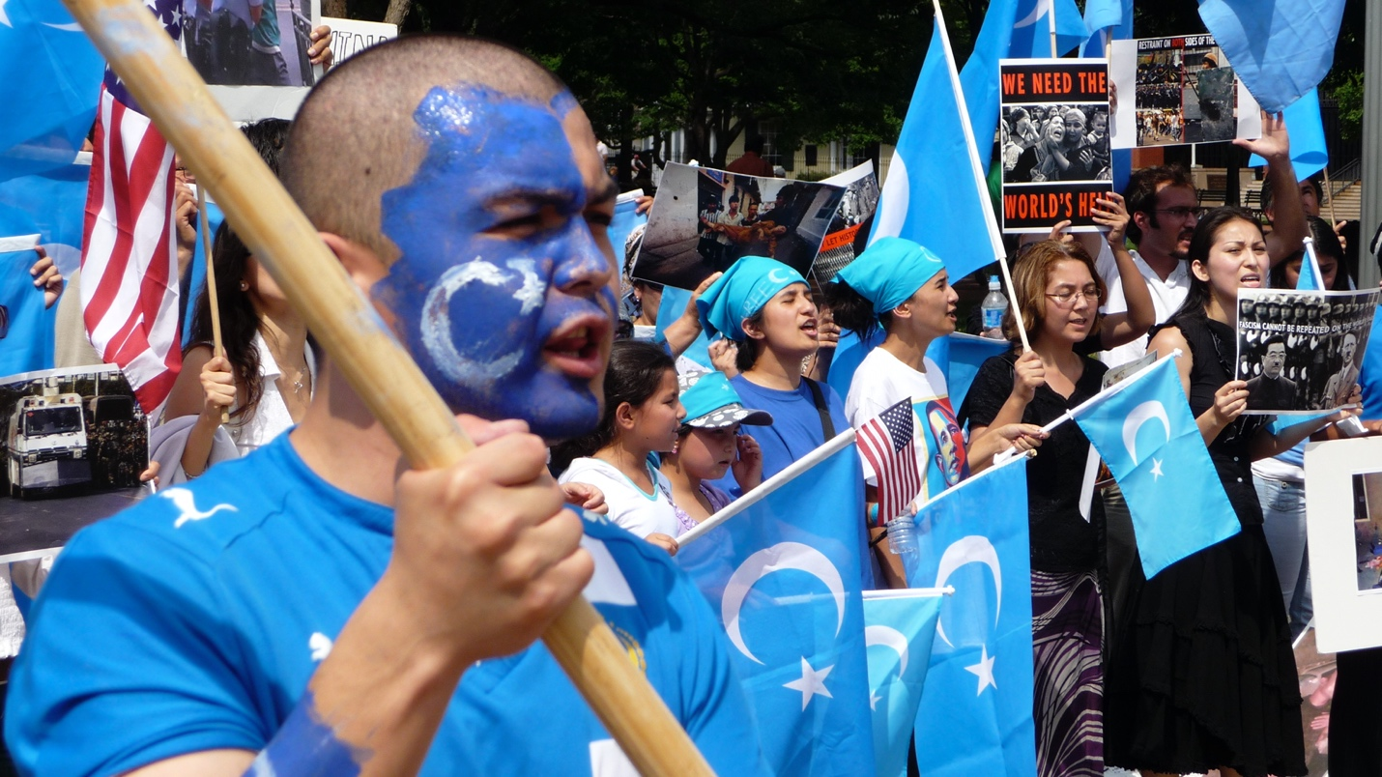

**Hannah Litty**

1. **Introduction**

Uyghurs are a Muslim ethnic minority group that lives primarily in the Xinjiang region of Northwest China.[1] The Uyghur population has endured a tumultuous history under the regime of Chinese authorities, extending all the way back to the 1950s. In 1953 the Xinjian Uyghur Autonomous Region was established and according to the first census of the region after autonomy was established, the Uyghurs made up more than 70 percent of the population.[2] However, since this first census, the Uyghur population has declined to make up roughly 50 percent of the population with the Han Chinese constituting much of the rest of the Xinjiang population.[3]

The following report will discuss the widespread and systematic campaign launched by the Chinese government against the Uyghurs as the reason for the disappearance of the Uyghurs. Through an analysis comparing the actions of the Nazi regime during the Holocaust to the Chinese government’s campaign against the Uyghurs, it is clear that the actions taken by the Chinese government against the Uyghur population constitute genocide under the 1948 Geneva Convention.

1. **The Crime of Genocide**

According to the United Nations’ Convention on the Prevention and Punishment of the Crime of Genocide defines genocide as killing, causing serious bodily or mental harm, deliberately inflicting conditions of life calculated to bring about physical destruction, imposing measures to prevent births and forcibly transferring children to other societal groups with intent to destroy, in whole or in part a national, ethnical, racial or religious group.[4] There are two elements to genocide that must be committed in order to constitute an international crime. The first element, which will be called element one for the purposes of this report, consists of any of the above-mentioned activities.[5] The second element, which will be called element two for the purposes of this report, requires intent to destroy a certain societal group while carrying out those activities.[6] The second prong of this crime against humanity can be the hardest to prove because an authorities intent to destroy a societal group can be shrouded in lies about security concerns or needing to deter terrorism. As explained later in this report, however, there are countless examples of atrocities committed against the Uyghurs by the Chinese authorities that clearly show the intent to destroy the minority. Additionally, the Chinese government utilizes many of the same tactics that were used by the Nazi regime during the Holocaust.

1. **Element One of Genocide**

The following section will compare the actions taken by the Chinese Authorities and how those actions fulfill element one, to the actions taken by the Nazi regime during World War II that fulfilled element one. The Nazi regime unquestionably conducted one of the most severe genocides in recent history and the reasoning for using that genocide as a comparison is to make clear that due to the similarities between the actions of Nazi regime and the actions of the Chinese government, the Chinese government is fulfilling element one the crime of genocide as we speak.

* 1. **The Actions of the Chinese Authorities**

Under the guise of eradicating the “three evils” of “ethnic separatism, religious extremism and violent terrorism” the Chinese authorities enacted and enforced restrictions on the religious practices of Uyghurs and other minorities in the Xinjiang region.[7] Under this guise, the Chinese government has created a large system of mass detention centers which the authorities have titled “vocational skills education training centers” and “education and transformation establishments” with the purpose to carry out “antiextremist ideological education.”[8] According to the United States Department of State, in 2018 the Chinese authorities passed regulations that stipulated

“institutions such as vocational skill education training centers should carry out training sessions on the common national language, laws and regulations, and vocational skills, and carry out antiextremist ideological education, and psychological and behavioral correction to promote thought transformation of trainees and help them return to the society and family.”[9]

In these centers, it is estimated that approximately 100 million Uyghurs are currently imprisoned or detained.[10] In an internal memo leaked from the Chinese authorities, it was stated that 15, 683 ‘suspicious’ people were taken into custody in a single week. [11] Those who end up in one of these detention centers have ended up there for owning books in Uyghur or sending a religious message to a family member, wearing a headscarf, or having a beard. [12]

Once inside the camps, detainees experience unspeakable forms of torture that are reminiscent of the torture inflicted at concentration camps in Nazi Germany during World War II. There have been reports of police detention facility staff beating detainees, hanging them from the walls and ceilings, subjected them to prolonged shackling and deprived them of sleep.[13] There have also been reports of detainees being shackled at their wrists and ankles and put into 420-foot cells with 40-68 other detainees for long periods of time with only a small hole in the ceiling for ventilation.[14] Aside from blatant torture, the living conditions in these camps are deplorable. Detainees are fed steamed buns and thin soup, forced to share beds with many other detainees and those who are seriously ill, or elderly are not given adequate medical care.[15]

In addition to living conditions inside these “education centers” life outside of these camps is not much improved for the Uyghur population. The Chinese government uses mass surveillance techniques to monitor the Uyghurs.[16] Using tactics such as encouraging people to inform on each other, placing police stations on street corners for tighter and more focused surveillance and forced collection of biometric data, China is able to maintain complete control over the minority population.[17]

Alongside mass surveillance to ensure that Uyghurs are not practicing religion or their culture, the Chinese authorities have gone to great lengths to erase the culture of the minority group in every aspect. Uyghurs are forced to attend weekly Chinese flag-raising ceremonies, political indoctrination meetings and Chinese language classes.[18] Speaking or writing the Uyghur language is discouraged, Uyghur cannot be taught in school and if state employees are caught teaching or speaking Uyghur they will be labeled a “two-faced person,” a label which has resulted in the detention of hundreds of Turkic Muslims.[19] Furthermore, the Chinese government has prohibited any expression of religion, they have confiscated prayer mats and Qurans, they have banned beards, headscarves and common Islamic names with religious connotations.[20] The authorities have also set up “burial management centers” which are in essence, giant crematoriums to conduct the cremation of Xinjiang residents to prevent Muslim burial traditions.[21]

These egregious acts are only the tip of the proverbial iceberg regarding the full scale of atrocities inflicted upon the Uyghurs and other minorities in the Xinjiang province. It might already seem very apparent the similarities that run throughout the actions taken by the Chinese authorities and the crimes committed by the Nazi regime during the Holocaust, however for the sake of this analysis it is important to highlight just how similar the actions of these two organizations actually are. An important note, the scale of the Holocaust was extreme – the Uyghur genocide is a much smaller scale, however the underlying similarities of the two events are nevertheless, very similar.

* 1. **Actions of the Nazi regime**

Prior to World War II, the persecution of Jews was already in full swing. The Nazi regime systematically limited Jews’ civil rights in Germany. The Nazis introduced the Nuremburg Laws in 1935 which granted the Nazis the ability to turn their racially discriminatory ideals into law.[22] Over time, these laws became more and more restrictive. These laws included restrictions such as requiring Jews to choose names from a government-approved list and requiring Jews to wear a yellow Star of David on the left breast of their clothing.[23] Additionally, Jews were unable to work as journalists and artists, the work of Jewish authors was burned and education for Jewish youth was extremely limited.[24]

During the height of the Holocaust, the Nazi regime employed the use of concentration camps and mass deportations. During this time, the Nazis attempted to disguise their true intent when forcing people to concentration camps – they referred to the removal of Jews from their homes to concentration camps as ‘resettlement in the East.’[25] The conditions in these concentration camps were hardly fit for human survival, and this proved true as there were few who survived to see their freedom at the end of the War.[26] It is generally understood that the purpose of these concentration camps were to incarcerate those whom the Nazi regime perceived to be a threat, eliminate minority groups and exploit forced labor from the prisoner population.[27] During this time before and during World War II, the Nazi regime murdered approximately 6 million Jews.[28]

An important note here, is the date and purpose for which the Genocide Convention was adopted by the General Assembly of the United Nations. The Genocide Convention was the first treaty adopted by the General Assembly, adopted on December 9th, 1948, and adopted to show the international commitment to ‘never again’ after the atrocities committed during the second world war.[29] However, that commitment seems to have escaped the international community in regard to the Uyghurs.

* 1. **Comparison of Chinese Authorities’ Action and the Nazi Regime**

The similarities between the Holocaust and the Uyghur genocide are both alarming and palpable. Not only is the use of concentration camps and extreme forms of torture common in both events, the purpose behind the use of these things is one and the same – destroy an entire group of people. The conditions in these camps which the Chinese authorities refer to as “vocational skills education training centers” and which the Nazis refer to as “resettling” are not fit for human survival. Not only does the Chinese authorities’ use of concentration camps mirror that of the Nazi regime, but the discrimination toward those also living freely in Xinjiang is alarmingly similar to the conditions imposed by the Nazis prior to and during World War II. The inability to practice religion and harsh repercussions for any displays of the minority culture are present in Xinjiang just as they were in Nazi Germany.

The fact that the crime of genocide was in essence created to prevent the very crimes committed during the Holocaust, and the actions of the Chinese authorities are hardly differentiable from the actions of the Nazi regime is damning evidence in favor of the torture inflicted on the Uyghurs constituting genocide.

1. **Element Two**

As mentioned earlier, the crime of genocide is a dual element crime requiring both action and intent. While the torturous acts committed within the walls of the “education centers” across Xinjiang constitute the first element of genocide – the act, it is the overwhelming destruction of the Uyghur culture outside the walls of those centers that cements the second element of genocide – intent.

As previously mentioned, the element of intent can be much harder to prove than the first element of action. It is largely more difficult to prove for the same reasons that intent is difficult to prove in any number of run-of-the-mill crimes such as larceny or murder – intent is a mental state. Additionally, intent can be difficult to prove in this situation when a group gives false reasoning for their actions. Here, the Chinese authorities have publicly stated that the “education centers” have a twofold purpose, the first being to teach mandarin and vocational skills, the second being to prevent citizens from exposed to and implementing “extremist ideals.”[30] In Nazi Germany, the separation and detainment of Jews was originally shrouded as the only way to defeat political opponents and snuff out unrest.[31]

Despite statements like these, the nature of the actions of both the Nazi regime and the Chinese government point toward the true intent behind them which is the eradication of minorities – in the Holocaust it was Jews, here it is the Uyghur population of Xinjiang. The Chinese government has implemented laws that forbid the very things that make the Uyghur population Uyghur. By banning the Uyghur language in both spoken and written form and any displays of religion, the Chinese government exposes their true intent to erase the Uyghur people and their culture.

1. **Conclusion**

A note about jurisdiction and the ability of the Chinese government to be held accountable in a court of law for their actions – as a party that has signed and ratified the United Nations Genocide Convention, China can be held accountable in the International Court of Justice for the crime of genocide.

In conclusion, on their own the actions taken by the Chinese government fulfill both elements of the crime of genocide, but when viewed in a comparative light to the actions taken by the Nazi regime during the Holocaust, it becomes even clearer that the world is turning a blind eye to a crime against humanity. The Chinese authorities are blatantly committing genocide against the Uyghur population and must be held accountable for their actions.

1. China Primer: Uyghurs, Congressional Research Service (2023) <https://crsreports.congress.gov/product/pdf/IF/IF10281>.
2. Historical Overview of Events Shaping the Politics of Xinjiang, Univ. Brit. Columbia (2020) <https://xinjiang.sppga.ubc.ca/timelines/historical-overview/>.
3. China (Includes Tibet, Xinjiang, Hong Kong and Macau) 2021 International religious Freedom report, U.S. Dept. State Off. Int’l Religious Freedom (2021), https://www.state.gov/wp-content/uploads/2022/05/CHINA-INCLUDES-TIBET-XINJIANG-HONG-KONG-AND-MACAU-2021-INTERNATIONAL-RELIGIOUS-FREEDOM-REPORT.pdf.
4. U.N. Convention on the Prevention and Punishment of the Crime of Genocide, Dec. 9, 1948, 78 U.N.T.S. 277.
5. Id.
6. Id.
7. Break their Lineage, Break Their Roots, Human Rights Watch (Apr. 19, 2019), <https://www.hrw.org/report/2021/04/19/break-their-lineage-break-their-roots/chinas-crimes-against-humanity-targeting>.
8. See supra note iii.
9. Id.
10. Chinese Persecution of the Uyghurs, U.S. Holocaust Memorial Museum (Feb. 23, 2024, 11:32 AM), <https://www.ushmm.org/genocide-prevention/countries/china/chinese-persecution-of-the-uyghurs>.
11. See supra note vii.
12. Id.
13. Id.
14. Id.
15. Id.
16. Human Rights Watch, supra note vii.
17. See id.
18. Id.
19. Id.
20. Id.
21. Id.
22. The Nuremburg Race Laws, U.S. Holocaust Memorial Museum (last visited Feb. 23, 2024 at 12:17 PM), <https://encyclopedia.ushmm.org/content/en/article/the-nuremberg-race-laws>.
23. Id.
24. The persecution of the Jews, Auschwitz-Birkenau Memorial and Museum (last visited Feb. 23, 2024 at 12:24 PM), <https://www.auschwitz.org/en/history/before-the-extermination/the-persecution-of-the-jews/>.
25. Ghettos and Deportations, Holocaust Memorial Day Trust (last visited Feb. 24, 2024 at 1:37 PM), <https://www.hmd.org.uk/learn-about-the-holocaust-and-genocides/the-holocaust/ghettos-deportation/>.
26. See generally Concentration Camps 1933-39, U.S. Holocaust Memorial Museum (last visited Feb. 24, 2024 at 2:04 PM), <https://encyclopedia.ushmm.org/content/en/article/concentration-camps-1933-39?series=10>.
27. Id.
28. How Many People Did the Nazis Murder?, U.S. Holocaust Memorial Museum (last visited Feb. 24, 2024 at 2;10 PM), <https://encyclopedia.ushmm.org/content/en/article/documenting-numbers-of-victims-of-the-holocaust-and-nazi-persecution>.
29. See supra note iv.
30. Lindsay Maizland, China’s Repression of Uyghurs in Xinjiang, Council on Foreign Rels. (Sept. 22, 2022), <https://www.cfr.org/backgrounder/china-xinjiang-uyghurs-muslims-repression-genocide-human-rights#chapter-title-0-4>.
31. See supra note xxvi.