***Panda*-monium: Analysis of China’s Panda Diplomacy Through the Lense of the UN Convention on Animal Health and Protection**

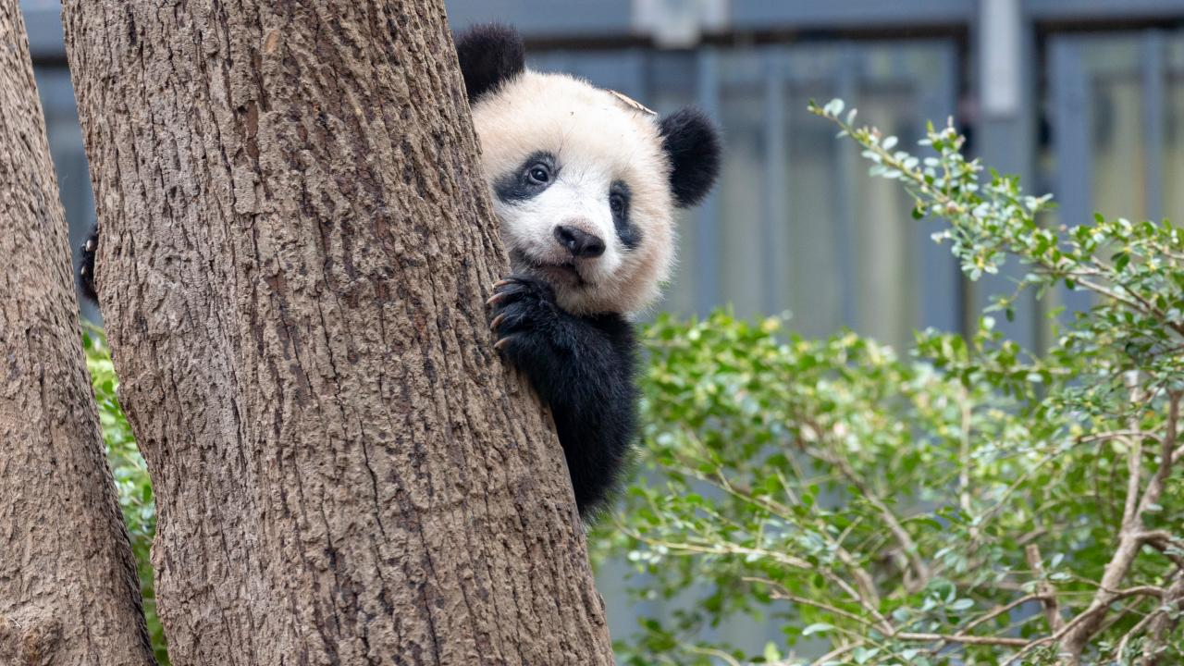

**Introduction**

Only four giant pandas are left in the United States, in the Atlanta Zoo. However, the pandas, Lun Lun, Yang Yang, Ya Lun, and Xi Lun, are expected to be returned to China in 2024.[1] When Chinese President Xi Jinping and Joe Biden had their first face-to-face, Xi stated that more pandas would most likely be sent back to the States.[2] He further described these pandas as “envoys of friendship between the Chinese and American peoples.”[3] This friendly exchange and “panda loaning” is not only seen between the United States and China. China’s “panda diplomacy” extends to various other nations to build relationships or simply as economic transactions.

The origin of panda diplomacy can be traced back to as early as the 1960s and 1970s.[4] During this time, China had just begun to open its economy to the international world.[5] This allowed more room for foreign opportunities, international trade deals, and a mixing of other global superpowers.[6] Slowly, China became one of the most economically powerful nations in the 20th century by strategically utilizing the use of public diplomacy and soft power to increase its attractiveness on the world stage.[7] “Soft” power encompasses diplomatic strategies in the form of influential network building, broadcasting compelling narratives, communications, and drawing on the resources that may make a country attractive or stand out internationally.[8] To China, it was their giant panda.[9]

Scholars have broken up the history of China’s panda diplomacy into three different phases, all creating a different motive for the panda exchange that is still in effect for China and the world today.[10] Phase I marks the beginning of China’s use of giant pandas as a strategic soft power.[11] China gifted its first pandas in 1965 to President Nikita Khurshchev of the Soviet Union and Kim Il-Sung of the Democratic People’s Republic of Korea.[12] These pandas were gifted by Chairman Mao Zedong, who recognized the uniqueness and value of these giant pandas.[13] From 1957 to 1983, Chairman Mao gifted a total of twenty-four pandas to nine nations as “goodwill ambassadors” and alliances with international states were formed.[14]

Phase II came under the rule of Chinese ruler Deng Xiaoping in 1978.[15] During this time, China went through a series of economic reforms leading to a more “open door” economic approach, especially with its Western neighbors.[16] The underlying motive for panda diplomacy shifted from the need for relationship building to a deeper emphasis on the Chinese market.[17] The exchange of giant pandas with other nations becomes a financial transaction with a capitalist lease model.[18] Between 1984 and 1987, China leased pandas to eight zoos for a fee of $50,000 US dollars per month per panda, which has since then increased. [19] Additionally, around this time, the International Union for Conservation of Nature listed the giant panda as an endangered species.[20] The Convention of International Trade in Endangered Species exclaimed that pandas should only be exchanged internationally for scientific purposes or to further the survival of the species.[21]

The last Phase III of the Chinese panda diplomacy comes shortly after the 2008 earthquake in Sichuan.[22] The Sichuan province is the center for a majority of China’s panda conservation efforts and contains much of the nation’s panda habitats.[23] Rebuilding and rehousing efforts after the earthquake were not easy.[24] Due to this unexpected phenomenon, China had to extend existing panda loans that it had with the international community.[25]Additionally, nearby nations that were still in the negotiation stage were offered pandas.[26]

**Impacts on Pandas**

Pandas are a national treasure to the People’s Republic of China, as China holds a global quasi-monopoly over pandas by being the only country with ownership of this species.[27] Giant pandas used to populate southern and eastern China, as well as neighboring nations of Myanmar and northern Vietnam.[28] However, due to overpopulation and human development, the panda population has dramatically decreased.[29] The giant panda’s diet consists mainly of bamboo, a native plant of Asia, with a majority in China.[30] Today, pandas are mostly found in the Minshan and Qinling mountains.[31] While efforts have been made to establish new reserves and increase conservation efforts, the impact of panda diplomacy and the residence of this species in a different country is a concern to many.

The case of panda Lele, a product of China’s panda diplomacy to the Memphis Zoo shows just how concerning and deadly this economic exchange can be.[32] Lele passed away just six weeks before his return back to his home in China.[33] However, he sadly passed away due to reportedly “heart disease.” However, various visitors and conservationists visiting the zoo could visibly see how underweight and distressed Lele was in his enclosure.[34] Several of these members even reach out to the Chinese Association of Zoological Gardens (CAZG) to address the poor quality of food and care provided to these pandas.[35] Despite CAZG's statement to the Memphis zoo, no change could be seen to improve Lele’s condition.[36]

Lele’s case is only one of the many concerns conservationists have regarding the ethical and ecological concerns of panda diplomacy. As a Berkeley Business Review article states, the line between conservation and commercialization has been blurred by the impacts of panda diplomacy.[37] Many conservationists worry about how increased interactions involving monetizing these pandas can greatly reduce the ecological value of these creatures. While pandas have been moved from the endangered species list, with more than 1,800 in the wild, they are still an extremely vulnerable species and could still face potential threats of habitat loss.[38]

**CITES Regulations**

The Convention on International Trade in Endangered Species of Wild Fauna and Flora is an international agreement between governments.[39] Its primary aim is to “ensure that international trade in specimens of wild animals and plants does not threaten the survival of the species.”[40] The treaty was borned out of the need for an international agreement after the world saw a significant increase in international trade.[41] These trades can be diverse, ranging from live animals and plants to other wildlife products derived from them (luxury bags, food products, leather goods, wooden musical instruments, etc.).[42] Annually, an estimated worth of billions of dollars are made from international wildlife trade.[43] Having an international agreement, such as CITES, in place can safeguard certain species from inhumane conditions and over-exploitation. Currently, there are around 184 parties that have signed onto the conservation agreement.[44]

With China’s accession to the CITES in 1981, the model for China’s panda diplomacy shifted from a commercial lease model to a conservation-oriented lease model.[45] In the United States, the U.S. Fish and Wildlife Service (FWS) is tasked to ensure the safety of pandas under the Endangered Species Act and CITES.[46] Under ESA, FWS must evaluate whether a proposed activity is likely to jeopardize the continued existence of the species and the survival of the species in the wild.[47] Under CITES, FWS must determine if proposed activity involving pandas would be detrimental to the survival of the species and must confirm that it is not primarily for commercial reasons.[48] The FWS established a panda policy consisting of six points that are used to provide guidance in the evaluation of the legality of China’s panda diplomacy.[49] The policy requires that: the pandas are used to conduct scientific research; public display will not interfere with research activities; importing the panda is not likely to jeopardize their continued existence in the wild; importing and studying pandas will benefit panda conservation and contribute to their survival in the wild; funds given to China for importing pandas are mainly used for panda conservation and monitoring; and the host zoo has adequate expertise and facilities to care for the pandas.[50]

Although no research has confirmed these violations, China’s panda diplomacy seems to threaten more than one of these policy points by the FWS. It is evident that these giant pandas are not solely used for scientific purposes. While China has shifted its model from a commercial lease model to a conservation-oriented model, not much has changed with the practice of panda diplomacy. China is still leasing these pandas out for a large amount of money, and it is unclear whether there is any scientific research going on behind the scenes. Additionally, it is unknown whether the money obtained from an exchange is panda conservation efforts. Considering the case of Lele and multiple other reports of questionable conditions in foreign zoos, it is also not a certainty that public display of these big animals are a beneficial factor to the existence and preservation of giant pandas.

**Conclusion**

While China is not the only country to employ the use of nonhuman animals as tools for diplomacy, with Australia using koalas, it is hard to see the controversy behind this literal use of *cuddly* and “soft” power. It is challenging to consider the ethical and ecological concerns regarding the transport, captivity, and overall meaning of these animals. The international community and the world often see these diplomatic exchanges from a “gift dimension” and mainly on social media.[51] The promotion of such sources creates a positive association between moving these animals further out of their natural territory and nation states receiving financial benefits for such an exchange.

An increase in China’s panda diplomacy, which will most likely happen, will not only threaten the panda’s chances of survival, as a species overall, in the wild, but also creates a bad precedent for the international community. This could increase the risk of exchanges of different species that may be disguised as animal diplomacies. This could also increase the risk of nations valuing the financial benefits over the conservation goals of these exchanges. In order to avoid these risks and violations of the CITES, it all starts with how the media portrays these animal diplomacies to the international community.

One thing in particular stood out when researching for concerns regarding panda diplomacy. It was challenging to find any sort of scientific research or reports on the conditions of these animals in transit and any ethical concerns involving shipping in animals from a completely foreign country/terrain. To better improve media portrayal and reporting, it is important to not report or describe these animals as “it,” “units,” or “specimens.”[52] These terms devalue the ecological value of the animal being described and merely sees them as an object. This may be a small step towards moving animal diplomacy in a positive direction but will be helpful in the long run with the expected increase in animal diplomacy. With more published scientific research, hopefully these animals will no longer be considered as mere objects of diplomacy, but as a meaningful diplomatic subject.

**Endnote**

1. Statement on Zoo Atlanta Giant Panda Program, Zoo Atlanta (2023), https://zooatlanta.org/statement-on-zoo-atlanta-giant-panda-program/
2. Didi Tang, Take heart, it looks like China could send new pandas to the US*,* AP News (2023), https://apnews.com/article/xi-jinping-pandas-apec94420197473c4152d6a2ce054c725873
3. *Id.*
4. Kathleen Carmel Buckingham, Jonathan Neil David & Paul Jepson, *Environmental reviews and case studies: Diplomats and refugees: Panda diplomacy, soft “cuddly” power, and the new trajectory in panda conservation*, 15 Environmental Practice 262–270 (2013).
5. *Id.*
6. *Id.*
7. *Id.*
8. Jonathan Mcclroy, *What is soft power?* The Soft Power 30, https://softpower30.com/what-is-soft-power/
9. *Id.*
10. *Id.*
11. *Id.*
12. *Id.*
13. *Id.*
14. *Id.*
15. *Id.*
16. *Id.*
17. *Id.*
18. *Id.*
19. *Id.*
20. *Id.*
21. *Id.*
22. *Id.*
23. *Id.*
24. *Id.*
25. *Id.*
26. *Id.*
27. Elena Lagrange, *Paying with Pandas*, Business Review at Berkeley (2023), <https://businessreview.berkeley.edu/paying-with> pandas/#:~:text=China%20holds%20a%20global%20quasi,debt%20to%20support%20the%20animals.
28. *Habitat: The land of the panda*, World Wide Fund, https://wwf.panda.org/discover/knowledge_hub/endangered_species/giant_panda/panda/where_panda_lives_habitat/ (last visited Feb 24, 2024).
29. *Id.* 
30. *Id.*
31. *Id.* 
32. *Paying with Pandas, supra* note 27
33. Brittany Michelson, *Update: Lele the Giant Panda dies of neglect after collapse at Memphis Zoo shortly before return to China,* In Defense of Animals (2023), https://www.idausa.org/campaign/wild-animals-and-habitats/latest-news/lele-giant-panda-death-memphis-zoo/ (last visited Feb 24, 2024).
34. *Id.*
35. *Id.*
36. *Id.*
37. *See* Elena Lagrange, *Paying with Pandas*, Business Review at Berkeley (2023), <https://businessreview.berkeley.edu/paying-with> pandas/#:~:text=China%20holds%20a%20global%20quasi,debt%20to%20support%20the%20animals.
38. *Habitat: The land of the panda, supra* note 28
39. *What is CITES?,* CITES, https://cites.org/eng/disc/what.php (last visited Feb 25, 2024).
40. *Id.*
41. *Id.*
42. *Id.*
43. *Id.*
44. *Id.*
45. *The People’s Republic of China’s panda diplomacy*, Congressional Research Service (2022), https://sgp.fas.org/crs/row/IF12122.pdf (last visited Feb 25, 2024).
46. *Id.*
47. *Id.*
48. *Id.*
49. *Id.*
50. *Id.*
51. Olatz Aranceta-Reboredo, *And What About the Animals? A Case Study Comparison Between China’s Panda Diplomacy and Australia’s Koala Diplomacy*, 2 Animal Ethics Review 88, 93 (2022).
52. *Id* at 90